SCAITALE: Development and Evaluation of a Noise-Aware, Code-Switching Multilingual Speech Recognition and Automated Summarization System for Hiligaynon Classroom Discourse

A Thesis Presented to
The Faculty of College of Computing and Informatics
Iloilo Science and Technology University
Iloilo City

In Partial Fulfillment
For the Subjects
CS - 8 Computer Science Thesis

By:

Andrei Tiangao
Dan Joseph Pedroso
John Nathan N. Fernandez

September 2026

Chapter 1

INTRODUCTION
This chapter presents the context and motivation of the study, focusing on the need for a localized educational technology prototype for multilingual Philippine classrooms. It discusses how environmental noise, intra-sentential code-switching across Hiligaynon, Filipino, and English, and the limitations of existing transcription and summarization systems affect the accessibility, comprehension, and retention of instructional content. The chapter also presents the background of the study, the research questions, the objectives of the study, the conceptual framework, the theoretical framework, the significance of the study, the scope and limitations, and the definition of terms.

Background of the Study
The integration of intelligent technologies in education has become an important response to persistent challenges in accessibility, comprehension, and student engagement. In multilingual and resource-constrained environments such as the Philippines, classroom settings present complex conditions shaped by linguistic diversity, environmental noise, and demands on student attention. As digital transformation continues to reshape educational practices, there is a growing demand for systems that not only capture instructional content but also support students in reviewing and processing information more effectively [1].
Effective communication lies at the heart of the teaching and learning process. Classroom instruction depends primarily on spoken interaction between teachers and students through lectures, discussions, and activities, making the accurate transmission and retention of spoken information essential for learning. Research has consistently demonstrated that communication quality directly influences student comprehension, participation, and academic outcomes [2]. As a result, the ability to accurately capture, review, and organize classroom discourse has become increasingly important, particularly in diverse and fast-paced educational environments where equitable access to learning materials cannot be taken for granted.
Recent advancements in automatic speech recognition (ASR) and natural language processing have enabled intelligent systems capable of transcribing and summarizing spoken content. These technologies have been applied across virtual assistants, meeting transcription platforms, and accessibility tools, and have shown potential for supporting lecture documentation and enhancing student learning [3]. However, most systems remain optimized for single-language, controlled recording conditions that bear little resemblance to real-world classrooms. Multilingual discourse, background noise, and spontaneous interaction significantly degrade ASR performance. Even advanced models such as Whisper, which demonstrate strong multilingual capabilities, still experience substantial accuracy degradation in noisy, domain-specific, and code-switching environments [4]. Another limitation is that most systems produce unstructured raw transcripts that do not constitute educationally meaningful outputs. Research demonstrates that structured lecture summaries can improve students' knowledge recall and satisfaction, as summaries reduce cognitive overload and support information retention [5]. Key concept summaries, definitions, and task-oriented notes may therefore provide more practical review support than raw transcripts alone.
Several commercial platforms have attempted to address transcription accessibility, including cloud-based tools such as Otter.ai, Fireflies.ai, and Fathom, which offer near real-time transcription and summarization capabilities. However, these systems are designed primarily for English-dominant and formal meeting environments. As a result, they provide limited support for low-resource Philippine languages, classroom code-switching, and educationally structured outputs that facilitate student understanding and knowledge retention within local classroom settings.
These technological shortcomings become even more consequential in light of the learning challenges students already face. Sustaining attention during classroom instruction is a persistent difficulty; one Philippine study found that approximately 89.7% of students exhibit low attention spans, which may affect their ability to engage with lessons [6]. Environmental noise can further intensify this problem. Research shows that noise impairs speech perception, reading ability, and memory performance, particularly among younger learners [7]. A systematic review of 26 studies found that environmental and classroom noise produces a consistent negative effect on the cognitive and academic performance of primary school children, with speech noise proving especially harmful to verbal working memory [9]. Prolonged exposure to road traffic noise at school has further been linked to slower development of working memory and attentional control in schoolchildren, which are cognitive functions that are foundational to processing and retaining spoken instructional content [10].
The problem is further complicated by the multilingual nature of Philippine classroom communication. In Western Visayas, instruction is routinely conducted across multiple languages, including Hiligaynon, Filipino, and English, often within a single lesson or sentence [8]. Research on Philippine classroom discourse consistently identifies code-switching not as an informal deviation but as a strategic and deliberate pedagogical choice informed by student needs and contextual demands. It is specifically used to clarify complex concepts, scaffold comprehension, and foster participation [11], [12]. While effective as a communicative practice, this linguistic fluidity presents a fundamental challenge for existing ASR systems, as low-resource Philippine languages are severely underrepresented in their training data and the systems are not designed to handle the intra-sentential switching that characterizes authentic classroom discourse in the region.
The consequences of this gap can be observed in classroom practice. When speech recognition systems fail in multilingual and noisy environments, critical instructional content becomes lost, inaccurately transcribed, or difficult to review effectively. Teachers remain dependent on manual note-taking or unstructured recordings that require significant post-class processing time. Students, meanwhile, may struggle to revisit key concepts, which can contribute to comprehension gaps. These classroom-level difficulties are also reflected in broader national data. The 2024 Functional Literacy, Education, and Mass Media Survey of the Philippine Statistics Authority found that while 90% of Filipinos possess basic literacy, only 70.8% demonstrate functional literacy, the ability to read, write, compute, and comprehend, including integrating information and making inferences, pointing to a systemic difficulty in processing instructional content within linguistically complex learning environments [13] .
Taken together, these challenges expose critical gaps in existing educational technology, including insufficient support for low-resource Philippine languages, poor handling of intra-sentential code-switching, lack of classroom-specific acoustic optimization, absence of role-aware transcription that distinguishes teacher speech from student speech, and failure to integrate transcription with structured and learning-oriented summarization. These gaps point to the need for a purpose-built solution designed around the realities of Philippine classrooms.
This study therefore proposes the development and evaluation of a prototype noise-aware, code-switching speech recognition and automated summarization system designed specifically for Philippine classroom environments. The proposed system processes classroom discourse involving Hiligaynon, Filipino, and English, with Hiligaynon treated as a low-resource language addressed through parameter-efficient fine-tuning and subjected to focused performance evaluation. By improving the accessibility, documentation, and usability of multilingual classroom discourse, this study contributes a context-aware and educationally aligned solution for learning environments in Western Visayas.
Objectives of the Study
General Objective
The study aims to design and develop a prototype teacher voice-prioritized multilingual classroom transcription and structured draft minute generation system that supports the clarity, accessibility, and usability of instructional content in multilingual classroom environments.
Specific Objectives
- To develop a system for capturing and processing classroom audio in noisy, real-world environments.
- To implement teacher voice identification using speaker embedding techniques to identify and prioritize instructional speech.
- To integrate a multilingual speech recognition model for transcribing code-switched classroom discourse involving Hiligaynon, Filipino, and English, adapting it to Hiligaynon through parameter-efficient fine-tuning, and to evaluate its performance under low-resource language conditions.
- To generate structured draft classroom minutes including topics, key points, definitions, and assigned tasks from transcribed speech.
- To evaluate the system's technical performance in terms of transcription accuracy, teacher identification accuracy, and processing time.
- To evaluate the system's usability through user-based assessment of usability, perceived usefulness, and perceived comprehension support.

Conceptual Framework
This study uses a conceptual framework structured as Input-Process-Output to show how multilingual classroom audio is processed, evaluated, and refined into the system this study proposes.
The inputs include multilingual classroom audio, teacher voice samples, reference transcripts, glossary terms, a Hiligaynon adaptation dataset composed of recorded and manually transcribed classroom speech, testing conditions, and, once the prototype is deployed for evaluation, user interaction and user feedback.
The process includes audio preprocessing, speech detection and segmentation, multilingual transcription with code-switch refinement, teacher voice identification, and structured minutes generation. Audio preprocessing prepares recorded speech for analysis, and speech detection separates speech from non-speech portions. Multilingual transcription converts speech into text using a recognition model adapted to Hiligaynon through parameter-efficient fine-tuning, applying code-switch refinement to each segment as it is produced to correct selected local and subject-related terms. Teacher voice identification then compares each transcribed segment against the enrolled teacher voice profile to distinguish teacher from non-teacher speech, and the final transcript is used to generate structured draft classroom minutes.
The outputs include the fine-tuned recognition model, generated and refined transcripts with teacher-prioritized content, structured draft classroom minutes, near-real-time subtitles, exported documents, and both technical and user evaluation results.
Evaluation combines technical and user-based measures. Technical evaluation uses Word Error Rate, teacher identification accuracy, precision, recall, and F1-score, and processing time, including a comparison between the complete fine-tuned system and an unmodified pretrained baseline. User evaluation is gathered through a questionnaire combining the standard System Usability Scale with additional items, to be developed, addressing perceived comprehension support, user experience, perceived usefulness, output clarity, and perceived accessibility support. Results from both guide the optimization of system settings before the prototype is finalized.
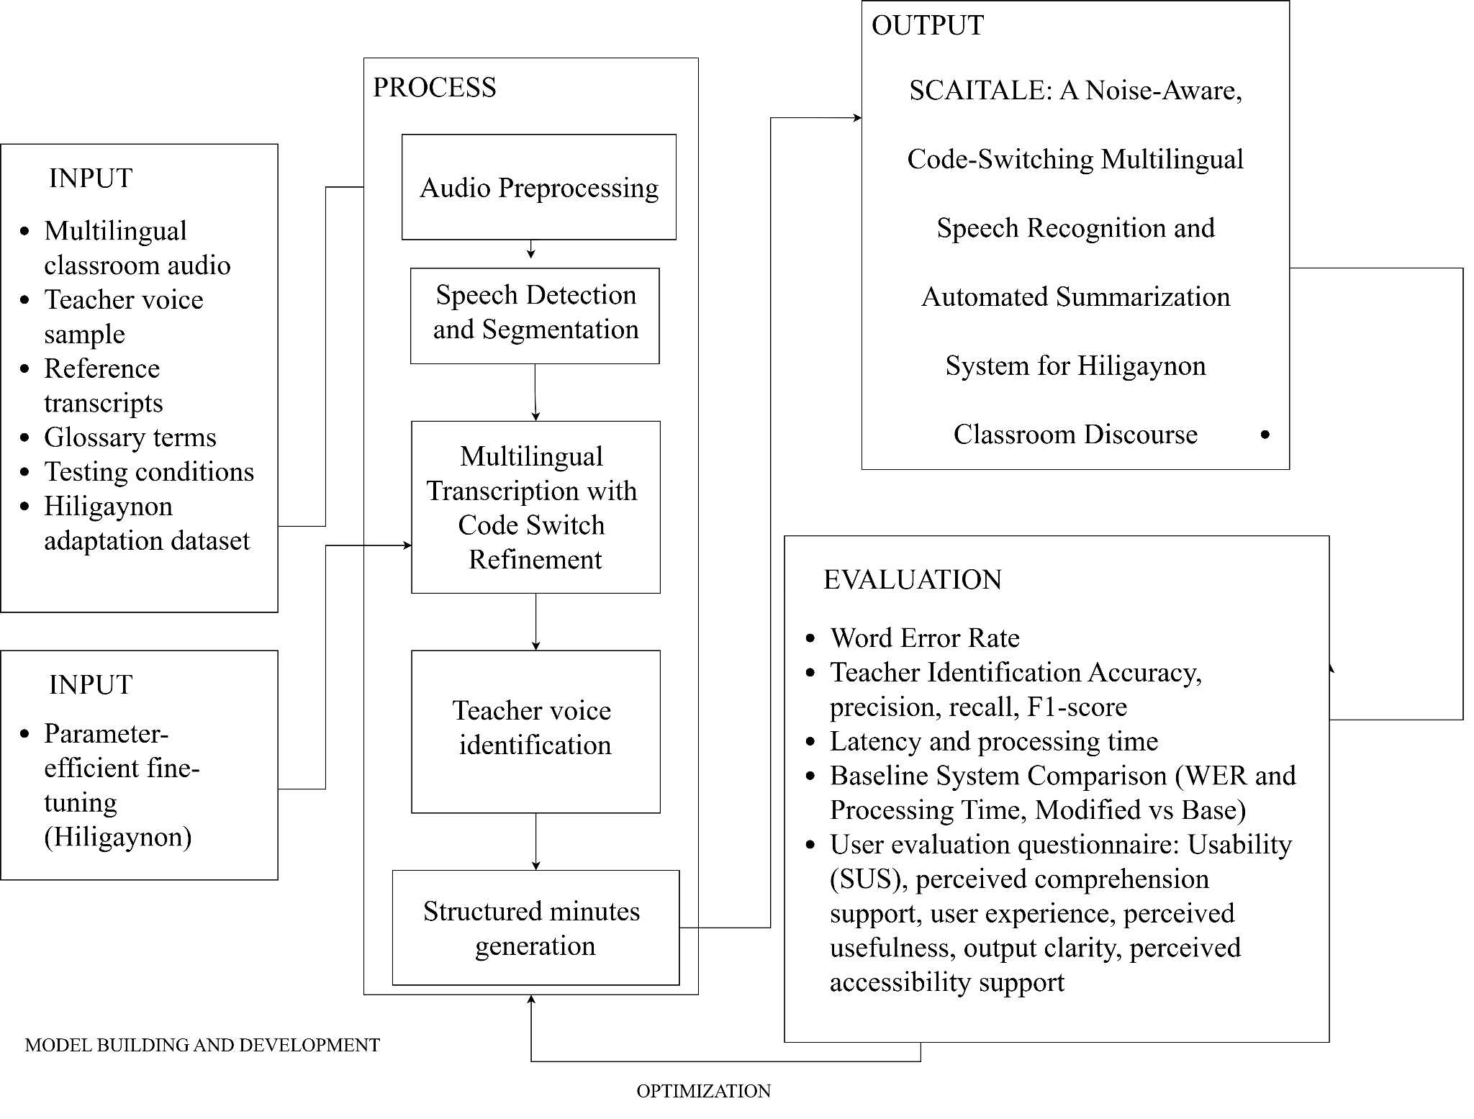

Figure 1. Conceptual Framework of the Study\

Significance of the Study
This study contributes to the advancement of knowledge in computer science, particularly in speech recognition, natural language processing, and educational technology. By developing a noise-aware, code-switching speech recognition and automated summarization system for multilingual classroom environments, the research addresses limitations in existing systems and introduces a context-specific approach for low-resource language settings. It also identifies gaps in multilingual and code-switching speech processing, providing a foundation for future research and development.

The findings of this study are expected to benefit several groups:
Students. The system may support comprehension by providing near real-time subtitles and structured draft learning materials. It can support students who struggle with attention, note-taking, and understanding multilingual instruction, allowing them to review key concepts, definitions, and discussions more effectively.
Teachers. Teachers may benefit from automated draft transcription and structured summaries of their lectures, reducing the need for manual repetition and documentation while improving instructional clarity and efficiency in delivering lessons.
Educational Institutions. Schools and universities can utilize the system to improve learning accessibility, particularly in multilingual and noise-prone classroom environments common in the Philippines, supporting more inclusive and technology-enhanced education.
Researchers. The study contributes to the development of low-resource language technologies, particularly for Hiligaynon, including a manually transcribed Hiligaynon classroom speech dataset and a recognition model adapted through parameter-efficient fine-tuning, and demonstrates the integration of artificial intelligence systems in localized educational contexts.
Future System Developers. The research provides a reference architecture for building noise-aware, context-aware speech systems, which can be extended into scalable applications such as mobile learning tools and near real-time educational support platforms.

Overall, this study contributes both theoretically and practically to the field of computer science by addressing real-world challenges in multilingual education and proposing a system that supports the clarity, accessibility, and usability of classroom instruction.

Scope and Limitation
This study focuses on the development of a prototype noise-aware, code-switching multilingual speech recognition and automated summarization system designed to process classroom audio captured in noisy and multilingual learning environments, supporting speech recognition for Hiligaynon, Filipino, and English classroom speech that contains intra-sentential and inter-sentential code-switching.
The system covers audio preprocessing, speech detection, multilingual transcription with code-switch refinement, teacher voice identification, and structured output generation, prioritizing teacher speech through voice enrollment, speaker embeddings, and similarity matching. The system generates instructional text outputs such as near-real-time subtitles, transcripts with teacher-prioritized content, and structured draft classroom minutes organized into topics, key points, definitions, and assigned tasks.
The primary dataset will consist of classroom audio collected within Western Visayas, with supplementary speech samples from church or similar noisy multilingual environments used only for preprocessing, noise-awareness testing, or additional speech variability analysis, not as a replacement for the classroom audio dataset as the main basis of the study.
The system will use pretrained models and existing algorithms for speech recognition, teacher voice identification, and summarization. It will not train an automatic speech recognition model from scratch due to limitations in time, dataset availability, and computational resources; however, the pretrained speech recognition model will be adapted to Hiligaynon through parameter-efficient fine-tuning using a curated dataset of recorded and manually transcribed classroom speech, with the prototype implemented using a mobile frontend connected to a backend processing pipeline.
The system will be evaluated using both technical and user-based measures. Technical evaluation will include transcription accuracy, Word Error Rate, teacher identification accuracy, precision, recall, F1-score, and processing time, including a comparison between the complete system and an unmodified pretrained baseline. User-based evaluation will include the System Usability Scale, supplemented by items addressing perceived comprehension support, user experience, perceived usefulness, output clarity, and perceived accessibility support. The respondents of the study will include selected students and teachers who will participate in prototype testing and evaluation within the research timeframe.
The study is limited by the availability of speech datasets for low-resource languages such as Hiligaynon, which may affect transcription accuracy, code-switch handling, and overall system robustness; the scale of the Hiligaynon adaptation dataset is likewise constrained by the recording and transcription effort feasible within the research timeframe, and the degree of improvement achievable through fine-tuning is itself subject to evaluation. Audio quality may also affect system performance, especially with strong background noise, overlapping speech, poor microphone placement, or varying speaker distance.
The study is also limited by hardware, time, and development constraints: the system's reliance on a backend processing pipeline does not guarantee full offline mobile deployment or iOS compatibility, and near-real-time processing may vary depending on audio length, chunk size, model size, device capability, and backend performance.
Full multi-speaker diarization is treated as an optional enhancement rather than a guaranteed feature; the study prioritizes teacher voice identification and teacher/non-teacher speech classification at the segment level, and if diarization tools such as pyannote.audio cannot be integrated within project constraints, the system will still evaluate teacher speech identification using speaker embeddings and similarity matching.
The findings of the study may have limited generalizability beyond the classroom environments, languages, speaker conditions, and audio settings used during data collection and testing. These limitations are acknowledged to keep the study feasible while maintaining focus on the development and evaluation of a working prototype.

Definition of Terms
Audio Segmentation. The process of automatically dividing a continuous audio recording or stream into discrete segments representing distinct units of content, such as speaker changes, topic transitions, or acoustic events like speech and silence [31].
In this study, audio segmentation is defined as the process of dividing classroom audio into shorter speech segments for preprocessing, speaker analysis, transcription, and near real-time subtitle generation.
Classroom Discourse. It is a communicative language used by teachers and students during interactions in the classroom, including both spoken discussions and written communication, capturing all forms of exchange that occur throughout lessons and fostering learning from teacher-led to student-driven conversations [32].
In this study, classroom discourse refers to the spoken exchanges between teachers and students involving Hiligaynon, Filipino, and English, during classroom instruction.
Code-Switching. This refers to the process of switching from a language or dialect to another in a social context, conversation or discussion. [33].
In this study, code-switching is defined as the occurrence of mixed-language speech (Hiligaynon, Filipino, and English) within classroom discourse, especially intra-sentential switching processed by the system.
Perceived Comprehension Support. Perceived comprehension support refers to the learner’s perceived enhancement of understanding and retention of information. This concept is grounded in the idea that comprehension involves the active construction of meaning from text [34].
In this study, perceived comprehension support is defined as the extent to which students believe the system helps them understand and review instructional content through captions, transcripts, and structured classroom minutes.
Functional Suitability. Functional suitability refers to the degree to which a system provides functions that meet stated and implied user needs under specified conditions [35].
In this study, functional suitability is defined as the accuracy and correctness of transcription, teacher voice identification, and summarization outputs.
Hiligaynon. Hiligaynon is an Austronesian language spoken by the Hiligaynon people, a member of the Bisayan language group, related to but not mutually intelligible with Cebuano [36].
In this study, Hiligaynon is defined as the regional language of Western Visayas used by the participants in their daily communication and classroom interactions.
Processing Time. Processing time refers to the measure of delay between input and output in a system, determining data processing efficiency [28]. In this study, processing time is defined as the duration required for the system to process an audio chunk and return the corresponding output .
In this study, latency is defined as the time between audio input and subtitle generation.
Multilingual Speech Recognition. It refers to the capability of a system to accurately transcribe spoken input across multiple languages, having also been trained from different languages [37].
In this study, multilingual speech recognition refers to the system’s use of a unified ASR model to transcribe classroom speech involving Hiligaynon, Filipino, and English, with Hiligaynon treated as a low-resource language subject to performance evaluation.
Noise Robustness. The ability of a model to maintain stable and meaningful representations and learn features that generalize well to new data even when the input is corrupted or contains random perturbations [38].
In this study, noise robustness refers to the system’s ability to reduce background noise and maintain usable transcription performance in classroom audio containing disturbances such as chatter, air conditioning, and ambient sounds.
Perceived Usefulness. Perceived usefulness refers to the degree of belief that a technology enhances performance [39].
In this study, perceived usefulness is defined as the extent to which users believe the system improves comprehension and learning.
Performance Efficiency. Performance efficiency refers to the degree to which a system performs its functions within specified time, throughput, and resource utilization parameters under defined conditions [29].
In this study, performance efficiency is defined as the system’s ability to generate outputs quickly with minimal delay.
Near Real-Time Subtitles. Near Real-time Subtitles, also known as live captions, are text generated in real time as someone is talking [40].
In this study, near real-time subtitles are defined as captions generated from classroom audio and displayed with a short processing delay during the class session.
Speaker Diarization. It refers to the process of segmenting an audio recording according to the speaker at hand [41].
IIn this study, speaker diarization refers to the optional process of segmenting classroom recordings by individual speakers, treated as an enhancement beyond the system's core teacher/non-teacher classification.
Speaker Embedding. Speaker embedding refers to a compact fixed-size vector representation of a speaker’s identity or speech characteristics, regardless of the length of the utterance [42].
In this study, speaker embedding refers to a numerical representation of a speaker’s voice used to compare classroom speech segments with the enrolled teacher voice profile.
Teacher Identification Accuracy. Teacher identification accuracy refers to the correctness of identifying speakers from audio [43].
In this study, teacher identification accuracy is defined as the system's ability to correctly classify teacher versus non-teacher speech.
Speech Recognition (Automatic Speech Recognition). The process of converting spoken signals into written text through a computational model developed with language and acoustic technologies [44].
In this study, speech recognition is defined as the use of Whisper-based models to generate textual transcriptions from classroom audio.
Structured Draft Classroom Minutes. Structured classroom minutes refer to organized summaries of discussions highlighting essential instructional elements [45].
In this study, structured draft classroom minutes are defined as system-generated outputs containing key points, topics, definitions, and assigned tasks, treated as draft materials subject to user review.
Transcription. The conversion of spoken language into written text by transcribing the contents of an audio file, where the resulting text varies according to the specific output channel used [46].
In this study, transcription is defined as the automated conversion of classroom audio into written text involving Hiligaynon, Filipino, and English speech.
Teacher Voice Enrollment. In this study, teacher voice enrollment refers to the process of collecting a short voice sample from the teacher to create a reference voice representation used for teacher identification and prioritization.
Teacher-Prioritized Transcription. In this study, teacher-prioritized transcription refers to the process of identifying teacher speech segments and giving them priority in transcription, captioning, and structured classroom minute generation.
Voice Activity Detection (Speech Detection). A signal-processing technique that distinguishes human speech from silence or background noise within an audio stream by outputting a binary decision for each audio frame to determine the presence of vocal activity [47].
In this study, voice activity detection is defined as the process of identifying speech segments in classroom audio and filtering out silence or non-speech portions before speaker analysis and transcription.
Voice Recognition. The ability of a program to identify a person based on their unique voiceprint by scanning speech and establishing a match with a desired voice fingerprint [48].
In this study, voice recognition is defined as the process of matching classroom speech segments against an enrolled teacher voice profile to identify and prioritize instructional speech.
Word Error Rate (WER). Word Error Rate is a metric used to evaluate transcript generation performance from speech by comparing predicted text with reference text [49].
In this study, Word Error Rate is defined as the primary metric used to measure transcription accuracy.
Filipino. Filipino is the national language of the Philippines, mandated through the educational system and used alongside regional languages and English in classroom instruction.
In this study, Filipino refers to the national language as used in classroom discourse; the ASR model processes this speech under its Tagalog language identifier, as Filipino is not represented as a distinct language class in pretrained multilingual speech recognition models.
Parameter-Efficient Fine-Tuning (PEFT). Parameter-efficient fine-tuning refers to techniques that adapt a large pretrained model to a new domain by training only a small set of additional parameters while keeping the original model weights frozen [75].
In this study, parameter-efficient fine-tuning refers to the adaptation of the pretrained multilingual speech recognition model to Hiligaynon classroom speech using Low-Rank Adaptation (LoRA) on a curated dataset of transcribed classroom recordings.

Chapter 2

REVIEW OF RELATED LITERATURE
This chapter reviews the theoretical and empirical literature that grounds the design and development of the proposed noise-aware, code-switching multilingual speech recognition and automated summarization system for and Hiligaynon classroom discourse. The review is organized into seven thematic areas: attention and comprehension in Philippine classrooms, effects of classroom noise on cognitive performance, code-switching in multilingual Philippine classrooms, the limitations of automatic speech recognition in low-resource and code-switched languages, automatic speech recognition in educational environments, real-time transcription and assistive learning technologies, and AI-based summarization and automated note generation. The chapter concludes with a review of directly related prior studies and a synthesis connecting the literature to the research gaps that the proposed system addresses.

Attention and Comprehension in Philippine Classrooms
Attention and comprehension are fundamental cognitive processes that influence how students understand and retain information during classroom instruction. Attention refers to the selective focus of conscious thought on specific information, enabling learners to engage meaningfully with learning tasks [50], whereas comprehension involves the construction of mental representations of information, integration of new input with prior knowledge, and the use of inference to bridge gaps in understanding. It extends beyond simple word decoding and involves a deeper understanding of ideas, concepts, and relationships conveyed through language [51]. These processes are particularly important in classroom discourse, where students rely heavily on listening and language processing to understand instructional content.
Studies have identified several factors that affect students’ attention and comprehension. Apilan [6] reported that students experiencing physical discomfort tend to have reduced attention spans, which negatively affects their ability to focus during learning activities. Similarly, Fernandez and Arriola [52] found that many primary learners fall under the frustration level in reading comprehension, indicating that difficulty in understanding instructional language leads to lower cognitive engagement in classroom tasks. Supporting these findings, research on junior high school students’ reading performance revealed that most learners remain at the instructional reading level and require guided support to achieve independent comprehension. The study further emphasized that linguistic knowledge, particularly vocabulary and grammar proficiency, significantly influences comprehension ability, while environmental conditions such as quiet and structured learning spaces enhance learning outcomes. In addition, anxiety and text difficulty were found to negatively affect comprehension, and many students struggle with higher-order skills such as inference and evaluation, highlighting the need for improved cognitive and instructional support systems [53].
These findings suggest that both physical, linguistic, and environmental factors influence how students process information in learning environments. When learners struggle with attention or comprehension, their academic performance and classroom participation are significantly affected, particularly in tasks requiring deeper cognitive processing.
Since this study focuses on the development of a noise-aware code-switching multilingual speech recognition and automated summarization system, understanding attention and comprehension is essential because these factors directly influence how students process spoken classroom discourse, especially in multilingual environments.

Effects of Classroom Noise on Cognitive Performance
Classroom noise refers to any unwanted or disruptive sound within the learning environment that interferes with students' ability to focus on and accurately process instructional input. Its sources are varied, including external disturbances such as traffic, construction, and outdoor activity, as well as internal disturbances such as student movement, overlapping conversations, and ambient classroom sounds. Regardless of origin, noise is widely recognized among educators and researchers as one of the most significant environmental threats to learning quality, consistently linked to increased stress, cognitive fatigue, reduced concentration, and diminished academic engagement [54].
The cognitive consequences of noise exposure are well-documented and extend across multiple domains of learning. A comprehensive review by Matthias Klatte, Kerstin Bergström, and Thomas Lachmann [7] synthesized findings from experimental and quasi-experimental studies on both short-term and long-term noise exposure in children, finding consistent negative effects on attention, memory, reading performance, and listening comprehension. Crucially, these effects were not limited to students with pre-existing learning difficulties; even typically developing learners showed measurable declines in cognitive performance under noisy conditions, suggesting that noise is a systemic barrier rather than an individual one. Longitudinal findings further indicated that prolonged exposure to classroom noise is associated with slower development of working memory and attentional control, which are cognitive functions foundational to processing and retaining spoken instructional content [10].
These findings are reinforced by research on classroom acoustic quality more broadly. A systematic review examining acoustic conditions across educational levels found that poor acoustic environments not only impair cognitive performance but also negatively affect students' emotional wellbeing, social interaction, and willingness to engage in classroom activities [20]. Importantly, the review noted that students' subjective perceptions of acoustic discomfort closely align with objective acoustic measurements, meaning students are acutely aware of noise as a barrier even when they cannot articulate it in technical terms. In some documented cases, targeted improvements to classroom acoustics were associated with cognitive performance gains of up to 15%, underscoring how consequential environmental sound conditions are to educational outcomes.
In Philippine classrooms, these challenges are not hypothetical. Classrooms in many public schools contend with high ambient noise levels arising from large class sizes, poorly insulated infrastructure, and proximity to outdoor activity. These conditions are particularly acute in regions such as Western Visayas, where classroom environments are rarely designed with acoustic management in mind. For students already navigating the cognitive demands of multilingual instruction, particularly when processing content delivered across Hiligaynon, Filipino, and English, the added burden of environmental noise creates compounding barriers to comprehension. An attentive student may still fail to accurately perceive spoken information when acoustic conditions degrade the signal itself. This reality makes noise not merely a background inconvenience but a direct technical obstacle, which any speech recognition system deployed in Philippine classrooms must be explicitly designed to overcome.

Code-Switching in Philippine Classrooms
Code-switching, which refers to the practice of alternating between two or more languages within a single conversation, lesson, or sentence, is not an anomaly in Philippine classrooms. It is a defining feature of how instruction is delivered and how students participate. Teachers shift between languages to clarify concepts, reduce comprehension barriers, and encourage student engagement, while students reciprocate by responding and interacting in whichever language best allows them to express their understanding. Far from being an informal deviation from classroom norms, code-switching functions as a deliberate and effective pedagogical strategy in Philippine multilingual educational environments.
Research conducted at Mariano Marcos State University documented code-switching in college classroom discourse through recordings, transcription, and in-depth interviews [55]. The findings confirmed that code-switching enhances comprehension by clarifying instructions and reducing language barriers, while also enabling students to generate responses, verify prior knowledge, and participate more actively in discussions. A subsequent study on multilingual dynamics in Philippine universities similarly found that situational code-switching, which involves shifting languages in response to contextual demands, is the most prevalent type observed in classroom settings [55]. Students in that study viewed code-switching positively, recognizing its role in improving classroom management, supporting comprehension, and promoting inclusive participation. A broader literature review examining 21 peer-reviewed studies from 2020 to 2025 further confirmed that strategic code-switching, when applied with pedagogical intent, serves as a scaffolding mechanism that supports second-language learners without abandoning the communicative resources of their first language [56].
What these studies collectively establish is not merely that code-switching happens in Philippine classrooms, but that it occurs systematically, purposefully, and at high frequency. In Western Visayas specifically, this multilingual reality is particularly layered. Classroom discourse in the region routinely involves not two but three languages, namely Hiligaynon, Filipino, and English, woven together within individual lessons and, critically, within individual sentences. This intra-sentential switching, in which a speaker transitions between languages mid-utterance, represents the most linguistically complex form of code-switching and the most technically demanding for automated systems to process. A sentence may begin in English, shift to Filipino for a grammatical connector, and conclude in Hiligaynon for conceptual emphasis, reflecting authentic communicative competence while simultaneously challenging the monolingual assumptions embedded in most existing speech recognition architectures.
Understanding the prevalence and structure of code-switching in Philippine classrooms is therefore not merely a sociolinguistic observation; it is a technical specification. Any speech recognition system intended for deployment in Western Visayas classrooms must be capable of handling this multilingual, intra-sentential reality in real time. The extent to which current ASR technologies meet that requirement is the central question addressed in the following section.

Limitations of Automatic Speech Recognition in Low-Resource and Code-Switched Philippine Languages
The limitations of existing ASR technologies in Philippine multilingual classroom contexts are not incidental; they are structural, arising from three compounding failure modes: systematic bias toward high-resource languages in model training, architectural inability to handle intra-sentential code-switching, and severe performance degradation under real-world acoustic noise. Each is independently documented in the literature, and their simultaneous occurrence in Western Visayas classrooms renders most off-the-shelf ASR systems fundamentally unsuitable for the task.
The dominant ASR systems currently in use, including Whisper and wav2vec 2.0, are trained predominantly on large corpora of high-resource languages such as English, Spanish, French, and Mandarin, creating a systematic capability asymmetry in which systems achieve near-human accuracy on well-resourced languages while producing substantially higher word error rates on languages with limited training data [57]. The root cause is data scarcity, not architectural weakness, as state-of-the-art ASR performance is tightly coupled to the volume, diversity, and quality of available labeled speech corpora [58]. Philippine languages occupy firmly low-resource positions in this landscape. Guevara et al. [18], in presenting the Philippine Languages Database covering Filipino, Cebuano, Kapampangan, Hiligaynon, Ilokano, Bikolano, Waray, and Tausug, explicitly note that previous Philippine language corpora were either domain-specific, non-parallel, or insufficiently sized for competitive ASR development, which typically requires hundreds of hours of labeled speech. Although Hiligaynon is included in that corpus, it remains underrepresented compared with high-resource languages and still lacks the scale of labeled speech data needed for robust classroom ASR performance. Aquino et al. [59] similarly found that even early ASR implementations for Hiligaynon served only as baseline systems requiring substantial further development. When existing ASR models encounter Hiligaynon speech, they may produce recognition errors not because the speech is unclear, but because the system has limited exposure to the language and its classroom-based code-switching patterns during training.
The second failure mode arises from the monolingual assumptions embedded in most ASR architectures. Standard ASR systems operate on the implicit assumption that a given utterance belongs to a single identifiable language whose acoustic and linguistic patterns remain consistent throughout. Code-switching violates both assumptions simultaneously. Mustafa et al. [60], in a systematic review of 42 experimental code-switching ASR papers, confirmed that accurate recognition of speech containing two or more languages within a single utterance remains an unresolved problem, with pronunciation variation at language-switching boundaries identified as a primary driver of cascading recognition errors. Even large-scale multilingual pre-trained models such as Whisper exhibit degraded performance on code-switching data despite high accuracy on each constituent language individually, because the model was not exposed to the specific alternation patterns during training [61]. Most code-switching ASR research addresses bilingual pairs such as Mandarin-English or Spanish-English, for which some specialized training data exists. The Hiligaynon-Filipino-English trilingual switching characteristic of Western Visayas classrooms represents a substantially more complex problem for which no dedicated training corpus or optimized ASR system currently exists.
The third failure mode concerns the acoustic mismatch between controlled training conditions and real-world classroom environments. Dua et al. [58] identify this training-testing mismatch as the leading cause of ASR performance degradation, with documented cases of word error rates increasing from single-digit percentages in quiet settings to values exceeding 90% under adverse acoustic conditions. Attia et al. [62] found that overlapping student speech, varying speaker distances, ambient background noise, and inconsistent microphone placement are the primary acoustic stressors in classroom ASR deployment, and that even state-of-the-art pre-trained models require substantial domain-specific adaptation before achieving reliable transcription accuracy in classroom audio. In Philippine public schools, where infrastructure limitations, large class sizes, and the absence of acoustic treatment compound these stressors, the gap between training and deployment conditions widens further.
Taken together, these three failure modes produce a compounding degradation effect that no commercial ASR platform is currently designed to withstand. Addressing this is not a matter of selecting a better off-the-shelf tool; it requires purposeful adaptation of model training, language resource development, and acoustic preprocessing specifically targeted toward the multilingual and noisy conditions of Philippine educational environments.

Automatic Speech Recognition in Educational Environments
The application of ASR in educational settings has expanded considerably over the past decade, driven by interest in automated lecture transcription, classroom analytics, and accessibility support for diverse learners. Research has demonstrated that ASR can reduce the cognitive demands of live note-taking, improve post-class review, and support students whose processing of spoken language is impaired by noise or multilingual instruction (Chern et al., 2017). However, educational environments impose specific technical demands that distinguish them from the controlled conditions for which most ASR systems are designed. Speaker variability, overlapping speech, spontaneous discourse, and background noise create an acoustic profile that exposes the limitations of systems optimized for clean, scripted audio [62]. Understanding both the current ASR landscape in educational deployment and the architectural choices that best address its constraints is therefore essential to justifying the design of the proposed system.
Among available ASR architectures, OpenAI's Whisper has emerged as the most consistently high-performing open-source option across diverse real-world conditions. Whisper is a transformer-based system trained on 680,000 hours of multilingual audio, giving it four properties particularly relevant to educational deployment: accuracy approaching human-level transcription, native multilingual capability, tolerance for background noise, and the ability to function without fine-tuning or forced alignment adjustments [4]. Independent evaluations of ASR services using higher education lecture recordings found that accuracy varies widely between commercial vendors and that streaming ASR, the mode used in live captioning, produces significantly lower quality than offline processing, highlighting the limitations of relying on standard commercial platforms for real-time educational deployment [63]. Research on classroom-specific ASR deployment further confirms that even state-of-the-art pre-trained models require domain-specific adaptation before achieving reliable transcription accuracy under real classroom acoustic conditions [62]. Critically for this study, Whisper is open-source and can be fine-tuned on custom datasets, adapted to domain-specific vocabulary, and deployed locally without external data transmission, making it the appropriate foundation for a system requiring adaptation to low-resource Philippine languages and classroom-specific acoustic conditions. These properties distinguish it from wav2vec 2.0, which requires supervised fine-tuning for competitive performance, and from Conformer-based architectures, which impose substantially higher computational requirements.
Before ASR inference can produce reliable transcriptions in classroom environments, input audio must be preprocessed to reduce acoustic noise and isolate speech from silence and background activity. These steps are not supplementary; as established in the previous section, the acoustic mismatch between training and deployment conditions is the primary driver of ASR performance degradation, and preprocessing directly reduces this mismatch before audio reaches the recognition model [58]. Voice Activity Detection is applied downstream using Silero VAD, which segments the audio stream into speech and non-speech intervals so that the ASR pipeline processes only acoustically relevant content. Research on classroom-specific ASR deployment confirms that integrating VAD as a preprocessing stage meaningfully improves transcription accuracy by ensuring recognition models operate only on segments containing active speech rather than silence or ambient background noise, reducing error propagation throughout the pipeline [62].
In multi-speaker classroom environments, raw transcriptions that do not distinguish between speakers produce outputs that are difficult to use for post-class review. Students need to know which segments represent teacher instruction and which represent peer contributions or background interaction. This is the function of speaker diarization, the process of segmenting an audio stream by speaker identity and answering the question of who spoke when throughout a recording [66]. This study implements diarization using pyannote.audio, which employs a powerset multi-class cross-entropy loss formulation for neural speaker segmentation that substantially improves over prior binary classification approaches [67]. Independent benchmark evaluations across 196.6 hours of multilingual audio found that pyannote achieves the best diarization performance among evaluated systems at a Diarization Error Rate of 11.2%, outperforming all competing open-source alternatives [68]. Plaquet et al. [69] further extended the pyannote framework by proposing a Mamba-based segmentation model that achieves state-of-the-art performance on multiple diarization datasets. Khoma et al. [70] confirmed that cosine similarity-based distance functions within pyannote's segment-level classification architecture yield reliable speaker identification in multi-speaker conversational audio.
Diarization alone assigns anonymous labels to speaker segments without identifying which speaker is the teacher. Teacher voice prioritization therefore requires a separate speaker verification mechanism. This study uses ECAPA-TDNN, implemented through the SpeechBrain toolkit, which extends the standard Time Delay Neural Network architecture with Emphasized Channel Attention, Propagation and Aggregation mechanisms, Res2Net modules, and squeeze-and-excitation blocks, yielding speaker embeddings that significantly outperform prior x-vector architectures on established verification benchmarks [71]. Thienpondt et al. [72] demonstrated that ECAPA-TDNN embeddings produce robust speaker representations under both close-talking and distant-talking conditions when applied to diarization contexts, outperforming prior embedding-based approaches on the AMI meeting corpus. Teacher identification is performed through cosine similarity matching between an enrolled teacher embedding and embeddings extracted from diarized segments. Cosine similarity is the standard scoring function for ECAPA-TDNN because the training objective maximizes intra-speaker compactness in embedding space, making angular distance an effective discriminant for determining whether two embeddings originate from the same speaker [71]. This approach requires only a brief enrollment recording from the teacher before each session, after which the system continuously flags teacher speech throughout the class to inform downstream transcription and summarization prioritization.
Standard Whisper, while accurate and multilingual, operates at inference speeds insufficient for near real-time captioning in live classroom settings. This study addresses the latency constraint using faster-whisper, a reimplementation of Whisper built on CTranslate2, an optimized C++ inference engine for transformer models. Faster-whisper achieves up to four times faster inference than the standard Whisper implementation at equivalent accuracy through layer fusion, padding removal, batch reordering, and 8-bit quantization support that further reduces memory consumption [73]. Macháček et al. [30], in developing Whisper-Streaming for live multilingual conference transcription, identified faster-whisper as the most recommended backend for streaming applications, demonstrating an average computationally aware latency of 3.3 seconds. The combination of preserved accuracy, reduced latency, and lower memory requirements makes faster-whisper the appropriate inference engine for continuous classroom audio processing within the timeframes needed to support live comprehension through subtitle delivery. The following section examines how real-time transcription output is structured for student access and what the literature establishes about the conditions under which near-live captioning most effectively supports comprehension and learning.

REVIEW OF RELATED STUDIES
HiligayNER: A Baseline Named Entity Recognition Model for Hiligaynon
Teves et al. [74] introduced HiligayNER, the first publicly available Named Entity Recognition model for Hiligaynon, presented at the 39th Pacific Asia Conference on Language, Information and Computation. The study constructed a corpus of over 8,000 annotated sentences drawn from news articles, social media posts, and literary texts, and fine-tuned two transformer-based models, mBERT and XLM-RoBERTa, on this dataset. Both models achieved over 80% in precision, recall, and F1-score across entity types, and cross-lingual evaluation with Cebuano and Tagalog demonstrated promising transferability to related Central Philippine languages. HiligayNER is the most directly comparable prior work addressing NLP for Hiligaynon and constitutes a foundational contribution to the field. However, the study operates entirely in the text domain and addresses entity recognition rather than speech recognition or transcription. It does not process audio, handle acoustic noise, address code-switching in spoken classroom discourse, or involve any classroom deployment. The proposed system extends the spirit of HiligayNER into the speech domain by addressing the absence of spoken language processing tools for Hiligaynon in real educational environments, particularly in noisy, code-switching classroom settings.

Philippine Languages Database: A Multilingual Speech Corpora for Developing Systems for Low-Resource Languages
Guevara et al. [18] presented the Philippine Languages Database (PLD) at LREC-COLING 2024, a multilingual speech corpus covering Filipino, English, Cebuano, Kapampangan, Hiligaynon, Ilokano, Bikolano, Waray, and Tausug, comprising over 454 hours of recordings across news, medical, education, tourism, and spontaneous speech domains. The corpus was developed in direct response to the insufficiency of prior Philippine language speech resources for training state-of-the-art ASR and text-to-speech systems. The PLD represents the most substantial structured speech resource available for Hiligaynon, and its inclusion in the corpus is directly relevant to the data foundation of the proposed system. However, the study is a corpus development effort rather than a deployed system. It does not implement an ASR pipeline, address classroom-specific acoustic conditions, handle code-switching across multiple languages in a single utterance, include speaker diarization or teacher prioritization, or produce educational outputs such as summaries or structured notes. The proposed system builds on the PLD as a resource while extending beyond corpus creation toward an integrated classroom transcription and structured summarization pipeline for Hiligaynon, Filipino, and English code-switched instructional settings.

CPT-Boosted Wav2vec2.0: Towards Noise Robust Speech Recognition for Classroom Environments
Attia et al. [62] investigated the use of continued pretraining (CPT) to adapt Wav2vec2.0 for classroom-specific ASR, submitted to ICASSP 2025. Using 5,235 hours of untranscribed classroom audio from the NCTE dataset, the study demonstrated that CPT reduces word error rates by over 10% compared to baseline models and improves robustness across different noise profiles, microphone types, and classroom demographics. This is the most directly comparable prior study addressing noise-aware ASR specifically in classroom environments and establishes that domain-specific pretraining is a necessary and effective strategy for classroom ASR deployment. However, the study operates exclusively in English and addresses a demographically homogeneous American elementary school context. It does not address multilingual discourse, code-switching, low-resource Philippine languages, or the trilingual switching patterns characteristic of Western Visayas classrooms. Speaker diarization, teacher voice prioritization, and summarization are entirely outside its scope. The proposed system addresses an analogous noise-awareness requirement but within a fundamentally different and more linguistically complex deployment context.

Turning Whisper into a Real-Time Transcription System
Macháček et al. [30] developed Whisper-Streaming, demonstrated at IJCNLP-AACL 2023, which converts Whisper's offline processing capability into a real-time streaming transcription system using a Local Agreement policy with self-adaptive latency. The system achieved an average computationally aware latency of 3.3 seconds on unsegmented long-form multilingual speech and was demonstrated in a live multilingual conference setting. Whisper-Streaming establishes that Whisper-based real-time transcription is technically achievable at latencies useful for live captioning, and its use of faster-whisper as the recommended inference backend directly informs the inference design of the proposed system. However, Whisper-Streaming is a general-purpose multilingual streaming tool with no optimization for Philippine languages, no capability for code-switching handling between low-resource regional languages, no speaker diarization or role-aware transcription, and no educational summarization component. It was evaluated in a formal conference setting and does not address the acoustic and linguistic conditions of noisy multilingual classroom environments. The proposed system adopts the streaming transcription principle established by Macháček et al. [30] while extending it with preprocessing, diarization, teacher prioritization, and summarization components specifically designed for the Philippine classroom context.

Using LLM-Supported Lecture Summarization to Improve Knowledge Recall and Student Satisfaction
Xie et al. [5], published in Expert Systems with Applications, developed a theme-based lecture summarization system combining graph-based theme segmentation algorithms and large language models, evaluating its effect on student knowledge recall and satisfaction in a higher education context. The study demonstrated that students exposed to AI-generated lecture summaries achieved significantly better knowledge recall than those provided with full unstructured transcripts, and that summarized content reduced cognitive overload while improving student satisfaction with post-class review materials. This study provides the most direct empirical grounding for the educational necessity of the proposed system's summarization component, confirming that summarization is not a supplementary feature but a substantive intervention with measurable learning benefits. However, the system operates on pre-existing English transcripts rather than integrating summarization within a real-time multilingual ASR pipeline. It does not address code-switched content, low-resource Philippine languages, classroom acoustic noise, or the technical challenges of generating coherent summaries from transcripts containing mixed-language utterances. The proposed system addresses the same educational need identified by Xie et al. [5] while situating the summarization component within a complete end-to-end pipeline designed specifically for multilingual Philippine classroom discourse.

REVIEW OF RELATED STUDIES
The seven thematic areas reviewed in this chapter do not present independent bodies of knowledge; they form a converging argument whose logical conclusion is the system this study proposes. Read together, they establish that the problem is real, that it is compounded, that existing technologies cannot resolve it as currently designed, and that the proposed system is a principled and necessary response.
The first two themes establish the educational foundation. Research on attention and comprehension in Philippine classrooms confirms that students do not passively receive spoken instruction, they process it under significant cognitive constraint, constrained by working memory limits, linguistic demands, and environmental conditions that collectively determine how much instructional content they actually retain. The literature on classroom noise deepens this picture by demonstrating that the physical learning environment is not a neutral backdrop but an active contributor to cognitive degradation, impairing speech perception, memory, and attentional control across all learner types, not only those with identified difficulties. These two themes together establish that the need for technological intervention in the Philippine classroom is not a matter of convenience — it is a matter of educational equity.
The third theme shifts the argument from the learner to the language. Code-switching in Western Visayas classrooms is not an anomaly or an informal deviation; it is the natural communicative form of multilingual instruction, occurring systematically and intra-sententially across Hiligaynon, Filipino, and English. This finding transforms the technical requirements of any proposed system: a solution that handles only one language, or that treats code-switching as noise rather than signal, is not merely suboptimal for this context — it is structurally misaligned with it.
The fourth theme explains precisely why that misalignment exists in current ASR technologies. The three compounding failure modes documented in the literature, namely high-resource language bias, monolingual architectural assumptions, and training-testing acoustic mismatch, do not merely reduce performance in Philippine classroom conditions; they produce the kind of cascading, compounding degradation that renders off-the-shelf systems functionally unreliable for the target environment. This is the technological gap the study addresses, and its root causes in training data scarcity, architectural design, and acoustic mismatch define the engineering requirements that the proposed system must satisfy.
The fifth and sixth themes survey the existing solutions that partially address these requirements and demonstrate where each falls short. The ASR landscape review establishes Whisper, pyannote.audio, ECAPA-TDNN, afftdn, and faster-whisper as individually well-validated tools with strong empirical support, while also confirming that none was designed for the specific combination of low-resource Philippine languages, trilingual code-switching, and classroom acoustic conditions. The real-time transcription literature confirms that live captioning is not interchangeable with post-hoc transcription — the immediacy of subtitle delivery during instruction produces educational effects that retrospective access cannot replicate, particularly for lower-proficiency learners navigating fast-paced multilingual discourse. The summarization literature closes the argument by demonstrating that transcription without summarization leaves students with outputs that are technically accurate but cognitively overwhelming, and that structured AI-generated summaries produce measurable improvements in knowledge recall and student satisfaction.
The related studies section confirms that no existing prior work integrates these capabilities in a single deployed system. HiligayNER established foundational NLP resources for Hiligaynon but operates entirely in the text domain. The Philippine Languages Database addressed the data scarcity problem at the corpus level but stopped short of system deployment. CPT-Boosted Wav2vec2.0 solved the noise-awareness problem for English classroom ASR but did not touch multilingual or code-switched speech. Whisper-Streaming enabled real-time transcription but without Philippine language optimization, diarization, or summarization. The LLM-based lecture summarization system by Xie et al. [5] demonstrated the educational value of AI-generated summaries but from pre-existing English transcripts rather than from a live multilingual pipeline. Each prior study addresses one layer of the problem. None addresses all layers simultaneously. The gap that runs across all five is precisely the gap this study fills.
The theoretical framework gives this argument its instructional grounding. Cognitive Load Theory explains why each pipeline component is necessary: every design decision targets a specific source of extraneous cognitive load in the Philippine classroom context. The Cognitive Theory of Multimedia Learning explains why real-time captions specifically are not redundant but compensatory under the degraded auditory conditions of noisy multilingual classrooms. Universal Design for Learning frames the system not as an assistive exception but as an inclusive default, designed for the full range of learner variability present in Western Visayas schools. Vygotsky's scaffolding principle explains why structured post-class outputs extend the system's educational function beyond the classroom session and into the independent review and internalization process. Together, these theories confirm that the proposed system is not simply a technical artifact, it is a theoretically grounded educational intervention whose design choices are motivated by established principles of how human learning works.
What the literature establishes, in its totality, is the following: Philippine students in multilingual classroom environments face compounding barriers to attention, comprehension, and knowledge retention that manual note-taking cannot address; existing ASR and transcription systems are structurally misaligned with the linguistic and acoustic realities of those environments; no prior deployed system combines noise-aware multilingual speech recognition, speaker-role-aware transcription, real-time captioning, and structured summarization in a single pipeline; and the theoretical principles of cognitive load management, multimodal learning, inclusive design, and instructional scaffolding collectively demand exactly the kind of system this study proposes. The development and evaluation of a noise-aware, code-switching speech recognition and intelligent summarization system for Hiligaynon classroom discourse is therefore not simply a response to an identified gap, it is the response the literature converges toward.

Chapter 3

METHODOLOGY
The increasing complexity of classroom environments in the Philippines presents significant challenges to student learning and comprehension. Despite relatively high basic literacy rates, many students continue to struggle with understanding instructional content due to factors such as reduced attention span, environmental noise and far-field audio conditions, and the multilingual nature of classroom communication [6], [7], [13]. The widespread use of intra-sentential code-switching, the practice of mixing languages such as Hiligaynon, Filipino, and English within a single sentence adds another layer of cognitive complexity for learners. While code-switching can aid in explanation and inclusivity, it can also increase cognitive load, making it more difficult for students to process and retain information effectively. As a result, there exists a gap between the delivery of instructional content and the level of understanding achieved by students.
Advancements in speech recognition and natural language processing offer promising opportunities to close this gap. However, most existing transcription and summarization systems are designed for formal, English-dominant environments and do not adequately support low-resource Philippine languages, code-switching behavior, or noisy classroom conditions. In response, this study proposes the development of a noise-aware, teacher-aware, multilingual classroom transcription and automated summarization system capable of processing classroom audio and generating structured instructional outputs. By integrating speech recognition, teacher voice identification, and automated summarization, the proposed system aims to improve comprehension, support note-taking, and enhance the overall learning experience of students in multilingual and noise-prone educational settings.

Project Description
This study focuses on the development and evaluation of a noise-aware, code-switching, multilingual speech recognition and automated summarization system designed for classroom discourse involving Hiligaynon, Filipino, and English. The system is developed to address persistent challenges in real-world classroom environments, including environmental noise, reduced student attention span, and the widespread use of intra-sentential code-switching, which collectively hinder comprehension and knowledge retention.
The primary goal of the study is to design and implement a system that captures classroom audio and transforms it into structured instructional outputs, near real-time subtitles, complete transcriptions, and automated summaries highlighting key concepts, definitions, and discussion points, incorporating speaker-aware processing, particularly teacher voice identification, to prioritize instructional content and improve output relevance.
This study adopts a developmental and experimental research design, in which a functional prototype integrating noise reduction, voice activity detection, teacher voice identification with optional speaker diarization, multilingual speech recognition, and extractive, rule-based summarization is developed and evaluated using both quantitative and qualitative methods.
The scope of the study is limited to a functional prototype built on pretrained models, focusing on system integration, targeted adaptation, and performance evaluation rather than training a speech recognition model from scratch or full institutional deployment; the pretrained recognition model is nonetheless adapted to Hiligaynon through parameter-efficient fine-tuning using a curated dataset of transcribed classroom speech
The system is evaluated based on both technical and user-centered metrics, including transcription accuracy, teacher identification accuracy, processing time, and usability, and is considered effective if it achieves acceptable performance under noisy, multilingual classroom conditions.
The expected outcome is a validated prototype demonstrating the feasibility of integrating multilingual speech recognition and automated summarization in classroom settings, with the potential to improve accessibility, comprehension, and learning support for students.

Project Development
The development of the proposed system follows a Hybrid Iterative Software Development Life Cycle (SDLC), selected because multilingual classroom transcription involves several uncertain factors, including classroom noise, code-switching, speaker distance, teacher and student speech overlap, and the limited availability of Hiligaynon speech resources. Rather than a single linear process, system modules are built incrementally, tested individually, integrated into a complete pipeline, and refined based on technical and user evaluation results, allowing weaknesses to be identified and addressed within the available development timeframe.
The development process is also aligned with the conceptual framework of the study, which structures the system's construction, deployment, and evaluation as a unified input-process-output model culminating in the developed and evaluated system.
The development process consists of the following phases:

1. Planning Phase
The Planning Phase defines the research problem, system objectives, scope, limitations, and target users, identifying the need for a multilingual, noise-aware, and teacher-prioritized classroom transcription and structured summarization system. Its main activities include reviewing related systems and technologies, identifying required features, selecting development tools, determining target languages, and preparing the initial development schedule, resulting in a prototype planned to support Hiligaynon, Filipino, and English classroom speech.
Output: Project proposal, system concept, scope and limitations, and initial development plan.
2. Requirements Analysis Phase
The Requirements Analysis Phase identifies the system's functional and non-functional requirements. "Functional requirements include classroom audio capture, audio preprocessing, speech detection and segmentation, teacher voice enrollment, multilingual transcription with code-switch refinement using a pretrained Faster-Whisper model, teacher voice identification using SpeechBrain's ECAPA-TDNN speaker embedding model, teacher-prioritized transcript generation, structured draft classroom minutes generation, and output export. Non-functional requirements include transcription accuracy, teacher identification performance, processing speed, usability, accessibility, reliability, and compatibility with the prototype environment. This phase also establishes teacher voice identification as a core feature, with full multi-speaker diarization treated as an optional enhancement depending on available time and hardware resources.
Output: Functional requirements, non-functional requirements, and process flow specification.

3. Design Phase
The Design Phase defines the system's structure: a mobile frontend handling audio capture, subtitle display, transcript viewing, and output access, and a backend handling audio preprocessing, speech detection, teacher voice identification, transcription, post-processing, summarization, and output generation. This structure is represented through the conceptual framework, Input-Process-Output model, Context Diagram, Level 1 Data Flow Diagram, and interface design, describing how classroom audio enters the system, how it is processed, and how outputs are returned to users.
Output: System architecture, process flow diagrams, data flow diagrams, and interface design.
4. Implementation Phase (Iterative Development)
The Implementation Phase develops the prototype incrementally, testing each module individually before integrating it into the complete system, using pretrained models and existing algorithms to keep the work feasible within the research timeframe.
Implementation follows the system's actual processing flow. Classroom audio is captured through the mobile application and streamed to the backend, where it is preprocessed through formatting, normalization, and noise-aware processing, then segmented using Voice Activity Detection. Each segment is compared against the enrolled teacher voice profile through speaker embeddings and similarity matching, then transcribed using a pretrained multilingual speech recognition model adapted to Hiligaynon through parameter-efficient fine-tuning. The transcript is refined through glossary-based code-switch post-processing, producing near-real-time subtitles, teacher-prioritized transcripts, structured draft classroom minutes, and exportable output files.
Output: Functional prototype with audio capture, backend processing, teacher voice identification, Hiligaynon-adapted multilingual transcription, transcript refinement, structured minutes generation, and output export.
5. Testing Phase
The Testing Phase evaluates whether the system modules and complete prototype function correctly, through unit testing of individual modules, integration testing of the assembled pipeline, and system testing of the full process from audio input to generated output. Technical evaluation measures transcription performance, teacher voice identification performance, and system responsiveness, using Word Error Rate, teacher identification accuracy, precision, recall, F1-score, and processing time, including a comparison between the complete system and an unmodified pretrained baseline.
Output: Technical test results, identified system errors, and areas for improvement.
6. Deployment and Evaluation Phase
The Deployment and Evaluation Phase tests the functional prototype in a controlled or simulated classroom setting. After teacher voice enrollment, the mobile application captures and streams classroom audio for processing, generating subtitles, transcripts, teacher-prioritized sections, and structured draft classroom minutes during the session. Afterward, selected students and teachers review these outputs and complete the evaluation instrument, measuring usability through the System Usability Scale and gathering open-ended feedback on comprehension, usefulness, and clarity.
Output: User feedback data, user evaluation results, and reviewed prototype outputs.
7. Maintenance and Refinement Phase
Based on the results of testing and evaluation, the system is refined to improve accuracy, performance, and usability, through adjustments such as optimizing preprocessing techniques, improving speaker recognition thresholds, and enhancing summarization outputs. This phase also identifies potential improvements for future development, such as expanded fine-tuning with larger speech datasets, additional language support, and system scalability.
Output: Improved system performance and recommendations for future work.
Alignment with Research Objectives
The phases of the SDLC are directly aligned with the objectives of the study. The implementation phase addresses the development objectives by integrating modules for audio capture, preprocessing, multilingual transcription, teacher voice identification, and structured summarization, with the recognition model adapted to Hiligaynon through parameter-efficient fine-tuning and the structured minutes module producing organized instructional outputs. The testing and evaluation phases address system performance and user acceptance: technical evaluation measures transcription accuracy, teacher identification accuracy, and processing time, while user evaluation measures usability through the System Usability Scale, supported by open-ended feedback on comprehension, usefulness, and clarity.

Requirement Analysis
This section presents the Context Diagram and Data Flow Diagram of the Prototype Multilingual Classroom Transcription and Structured Minutes Generation System, providing a clearer understanding of the system's process, data movement, and interaction between users and system components. The requirements analysis also includes pseudocode representations of the major system function to describe how the system processes classroom audio and generates instructional outputs.
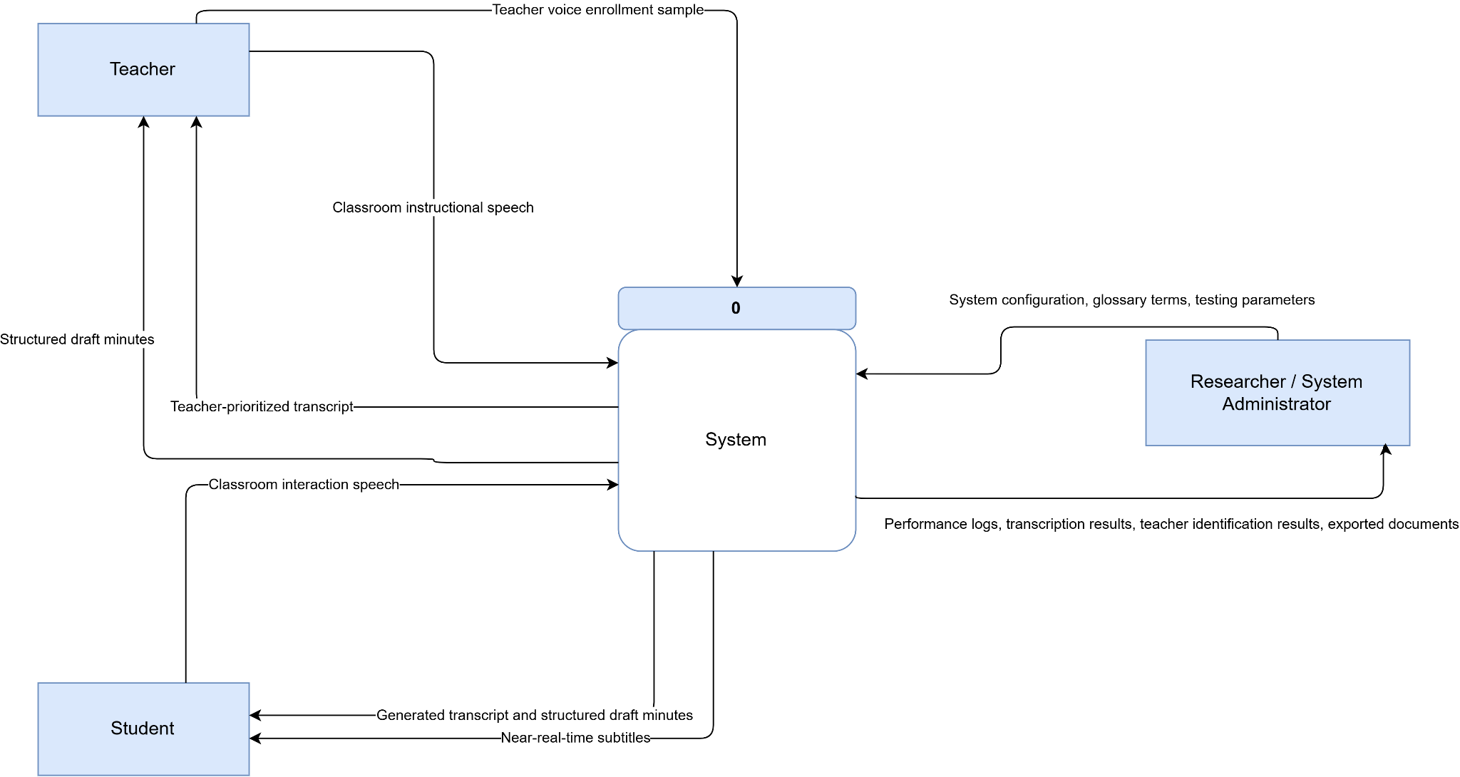

Figure 2. Context Diagram (Level 0) of the Prototype Multilingual Classroom Transcription and Structured Minutes Generation System
The Context Diagram shown in Figure 2 presents the proposed system as a central process interacting with three external entities: the Teacher, the Student, and the Researcher/System Administrator. The Teacher provides the voice enrollment sample and classroom instructional speech, receiving the teacher-prioritized transcript and structured draft minutes. The Researchers/System Administrator provides the system configuration, glossary terms, and testing parameters, and receives performance logs, transcription results, teacher identification results, and exported documents.
The diagram also defines the system boundary, showing that audio preprocessing, teacher voice identification, multilingual transcription, code-switch post-processing, and structured draft minute generation are all handled within the system.
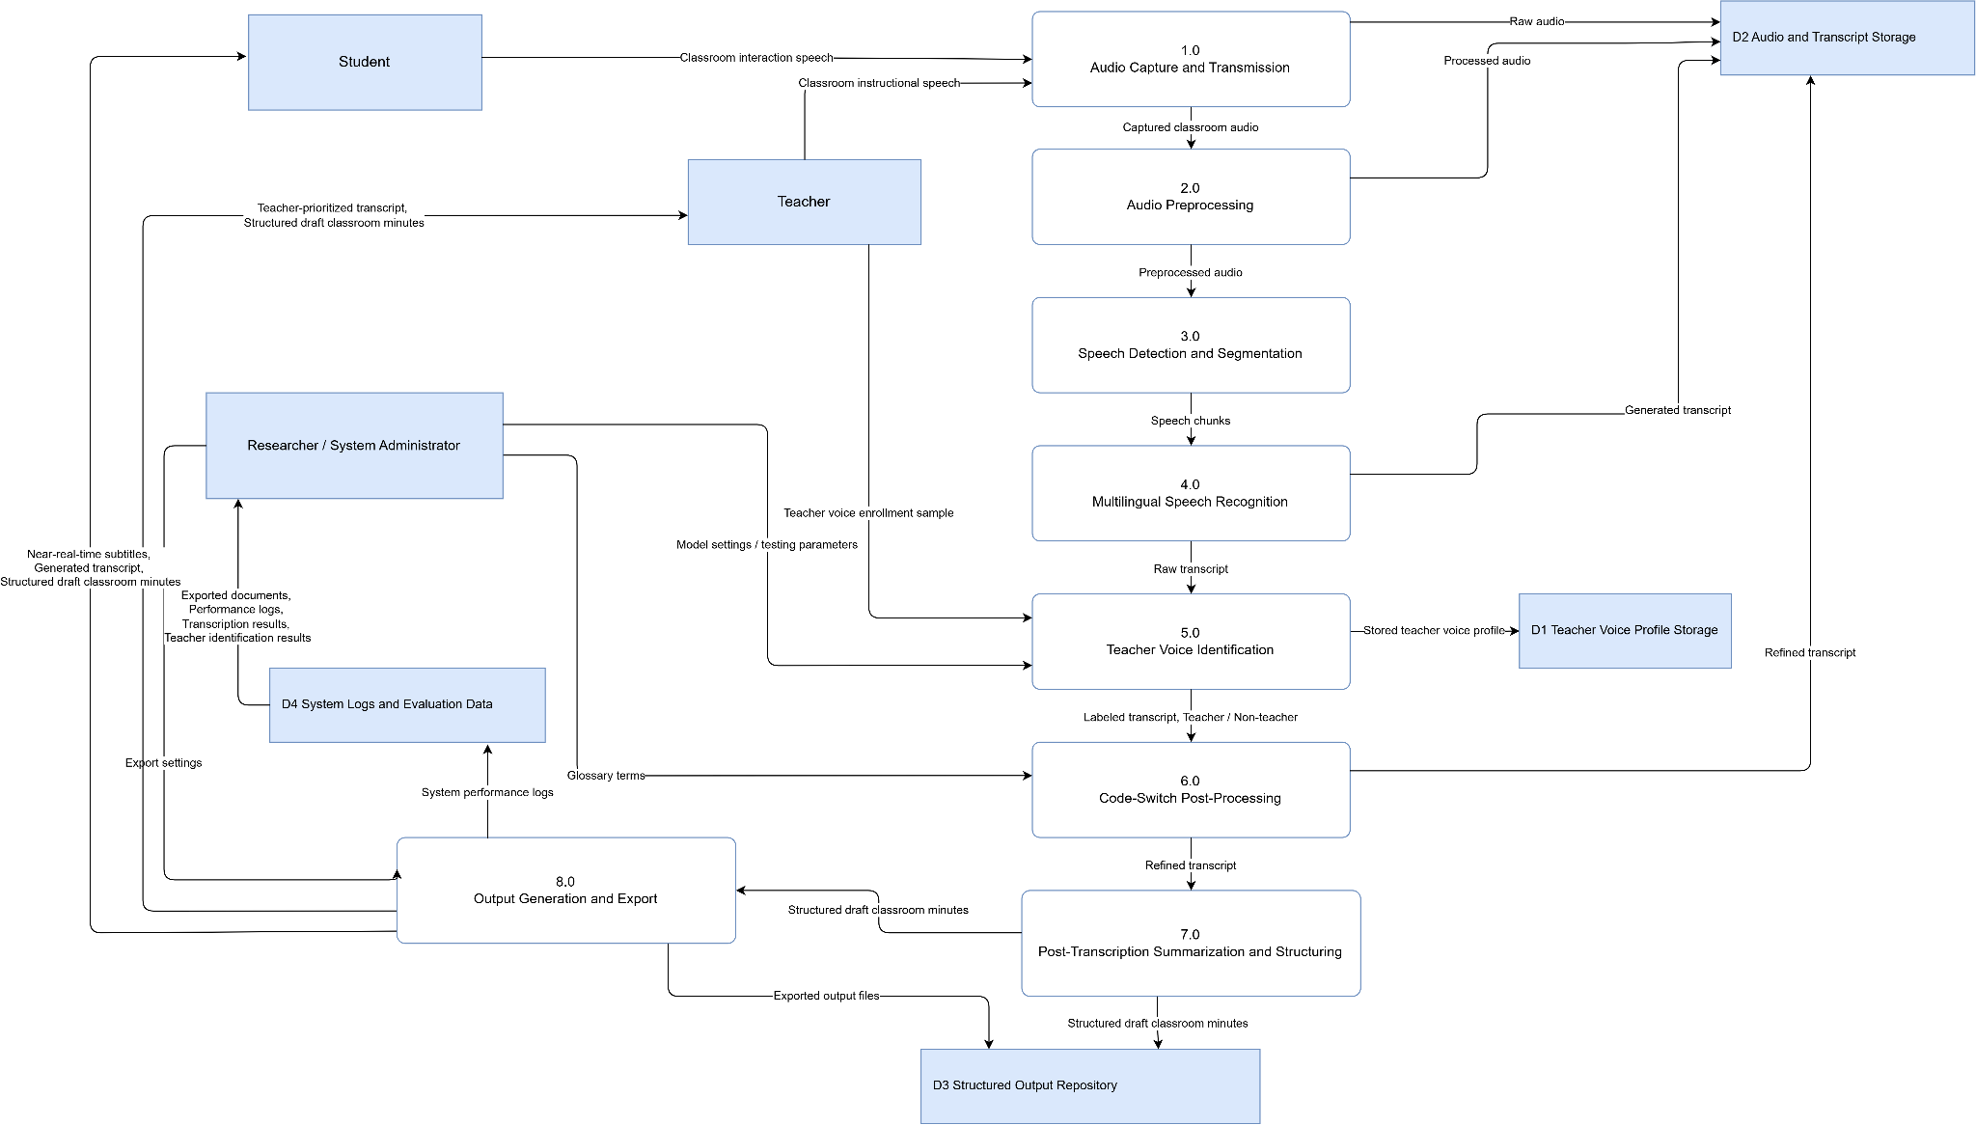
Evaluation respondents are not included in the Context Diagram because their role belongs in the Testing and Evaluation section rather than the operational data flow of the prototype system.

Figure 3. Data Flow Diagram (Level 1) DFD of the Prototype Multilingual Classroom Transcription and Structured Minutes Generation System
The Level 1 Data Flow Diagram shown in Figure 3 breaks the main system process down into smaller functional processes, showing how classroom audio is captured, processed, transcribed, identified, refined, summarized, stored, and delivered to users.
The process begins when the Teacher provides a voice enrollment sample, which is processed and stored as a teacher voice profile. During a classroom session, the system captures classroom audio through the mobile application, streams it to the backend, and converts, normalizes, and processes it for noise reduction.
After preprocessing, the system performs speech detection and segmentation using Voice Activity Detection, dividing detected speech into smaller chunks for near-real-time processing.
Each chunk is then transcribed using a pretrained multilingual automatic speech recognition model adapted to Hiligaynon through parameter-efficient fine-tuning, focused on Hiligaynon, Filipino, and English code-switched classroom speech. The audio corresponding to each resulting transcript segment is compared with the stored teacher voice profile through speaker embeddings and similarity matching, identifying whether the segment belongs to the teacher or a non-teacher speaker, optionally supported by full speaker diarization. The generated text is then refined through glossary-based code-switch post-processing.
Once the transcript is completed, the system performs post-transcription summarization and structuring, prioritizing teacher-labeled content, to generate draft classroom minutes containing topics, key points, definitions, and assigned tasks.
The final outputs include near-real-time subtitles, teacher-prioritized transcript sections, full transcripts, structured draft classroom minutes, and exported document files, used by students for review, teachers for instructional reference, and researchers for system evaluation.

Model adaptation through parameter-efficient fine-tuning is performed offline during the model building phase and is not represented in the runtime data flow. Speaker diarization remains an optional enhancement depending on time and hardware resources; the core system relies on teacher voice identification through speaker embeddings rather than full diarization of all classroom speakers.

Pseudocode
The proposed system follows an audio-to-text processing workflow. It begins with teacher voice enrollment, followed by classroom audio capture, preprocessing, speech detection, teacher voice identification, multilingual transcription, code-switch post-processing, subtitle generation, and structured draft minutes generation.

Script 1. Pseudocode for Teacher Voice Enrollment
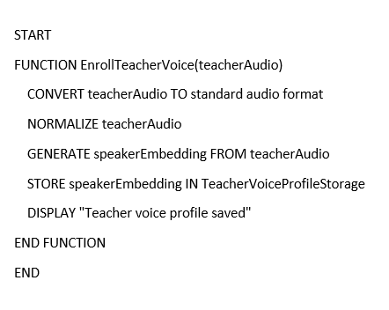

The system processes the teacher's voice enrollment sample by converting it to a standard 16kHz mono format, matching what the downstream verification and recognition models expect, and normalizing its loudness, since a teacher's enrollment sample and a later classroom segment are rarely captured at the same recording gain. A speaker embedding is then generated using SpeechBrain's pretrained ECAPA-TDNN model and stored as the teacher voice profile, with the system supporting multiple enrolled teachers per deployment. Because this model is trained on VoxCeleb, a general-purpose dataset of largely English-language interview audio, rather than Hiligaynon, Filipino, or English classroom speech, its similarity threshold for identifying teacher speech is treated as an unvalidated default subject to evaluation.

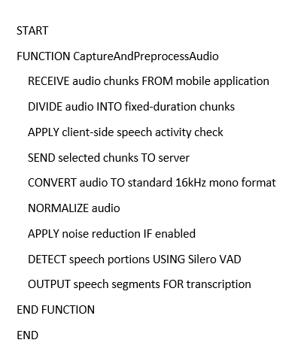
Script 2. Pseudocode for Audio Capture and Preprocessing

The mobile application captures classroom audio and transmits it to the server through a WebSocket connection in fixed-duration chunks, allowing audio to be processed while recording is still ongoing for near-real-time transcription. Before transmission, a lightweight energy-based speech activity check is applied on the mobile device to reduce the sending of silent audio while retaining chunks near speech boundaries. On the server, each received chunk is converted to a standardized 16 kHz mono PCM WAV format and undergoes loudness normalization to provide a consistent input for subsequent processing.
Optional noise reduction is then applied using FFmpeg’s afftdn filter to reduce classroom background noise such as ambient sounds and surrounding activity. After preprocessing, Silero VAD detects the actual speech portions within each already-created audio chunk and provides the speech boundaries for the transcription stage. The client-side speech activity check and server-side Silero VAD serve different purposes: the former determines whether an audio chunk should be transmitted, while the latter identifies speech segments for transcription. Thus, fixed-duration chunking supports continuous near-real-time transmission, whereas VAD-based segmentation reduces the amount of non-speech audio processed by subsequent stages.

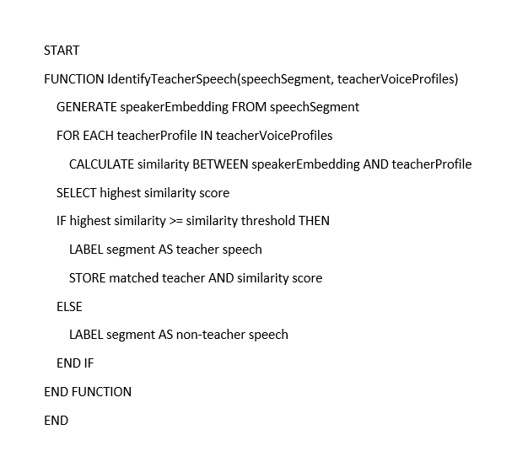
Script 3. Pseudocode for Teacher Voice Identification

The system identifies teacher speech by comparing each Whisper transcription segment against the stored voice profile of the enrolled teacher. Rather than comparing the original fixed-duration streaming chunk, the system extracts the corresponding portion of the original waveform using the start and end timestamps of each Whisper segment, providing a more speech-focused unit for speaker verification. A speaker embedding is generated from the segment using SpeechBrain's pretrained ECAPA-TDNN model and compared with the enrolled teacher embedding using cosine similarity.
When multiple teacher profiles are available, the system selects the highest-scoring profile and classifies the segment as teacher speech only when the similarity score meets the configured threshold; otherwise, it is treated as non-teacher speech. The resulting segment retains the teacher classification, matched teacher name when applicable, and similarity score for subsequent analysis. Teacher verification operates independently from speaker diarization, allowing the system to identify whether speech belongs to an enrolled teacher without requiring full multi-speaker diarization.

Script 4. Pseudocode for Multilingual Transcription and Code-Switch Processing
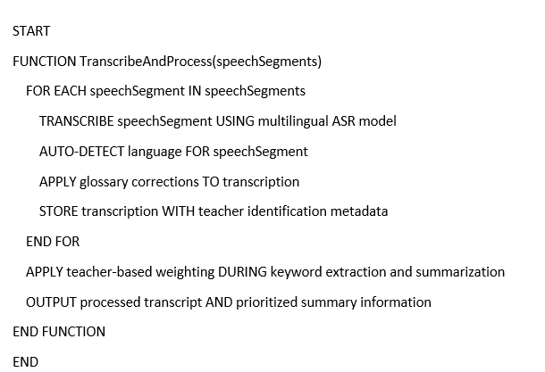

The system transcribes speech segments identified by Silero VAD using Faster-Whisper, a pretrained multilingual automatic speech recognition model configured for CPU inference. Each speech segment is processed independently without forcing a specific language, allowing the system to automatically determine the language of individual segments and accommodate switching among Hiligaynon, Filipino, and English. After transcription, a glossary-based correction process applies predefined corrections to selected terms to improve the consistency and accuracy of the resulting text.
The corrected transcription is stored together with the teacher-identification metadata generated in the previous stage. Rather than creating a separate teacher-prioritized transcript, the system applies teacher-based weighting during subsequent keyword extraction and summary generation, giving teacher-labeled segments greater influence on the identification of keywords and key points. This allows the chronological transcript to remain intact while prioritizing instructional speech in the generated outputs.

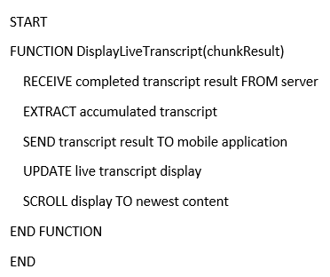
Script 5. Pseudocode for Subtitle Generation

The system delivers completed transcription results to the mobile application through a WebSocket connection as each processed audio chunk becomes available. Each result contains the newly transcribed text and the accumulated transcript generated up to that point, allowing the mobile application to continuously update the displayed transcription while the recording session is ongoing. Upon receiving a result, the application replaces the current displayed transcript with the updated accumulated version and automatically keeps the newest content visible for the student. This provides a near-real-time live transcript that students can follow during classroom discussions.
The output is treated as a live growing transcript display rather than traditional timed subtitles, since the system does not use caption cues, fixed display durations, or synchronized subtitle lines. Processing delays may cause the displayed transcript to lag behind the live discussion, but completed results continue to be delivered as individual chunks are processed.

Script 6. Pseudocode for Structured Draft Classroom Minutes Generation
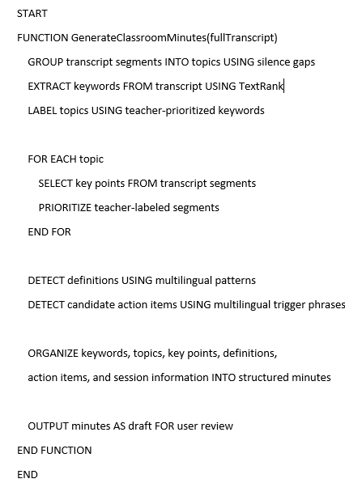

The system generates structured classroom minutes after the complete session transcript has been assembled, rather than processing individual audio chunks. It first groups transcript segments into topic blocks using significant gaps in speech as a heuristic indicator of topic transitions, then extracts keywords using a TextRank-based co-occurrence analysis with teacher-labeled speech given greater weight. These keywords are used to produce topic labels, while key points are selected from each topic by prioritizing teacher speech and then considering segment length.
Definitions are identified through predefined multilingual linguistic patterns for English, Filipino, and Hiligaynon, while candidate action items are surfaced by detecting predefined task-related phrases and retaining the matching sentences with their timestamps and speaker information. The resulting keywords, topics, key points, definitions, action items, and session information are organized into a structured minutes record that can be viewed or exported by the user. Because these outputs rely on heuristic topic segmentation, pattern matching, keyword ranking, and teacher identification rather than a dedicated semantic summarization model, the generated minutes are treated as a draft that may require user review and correction.

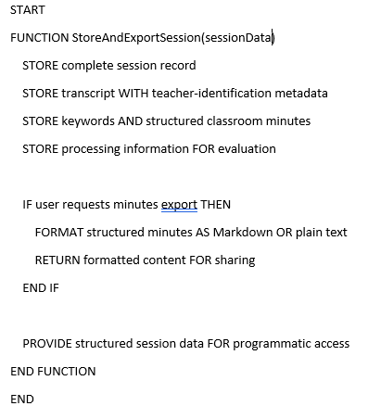
Script 7. Pseudocode for Output Export

The system stores the completed session in a structured session record containing the source chunk results, the materialized transcript and its segment-level teacher-identification metadata, extracted keywords, generated classroom minutes, and processing information used for evaluation.
The transcript is retained as a single chronological record rather than as a separate teacher-prioritized transcript, with teacher labels and similarity information attached to individual segments for use by downstream processes. For user-facing export, the structured classroom minutes are formatted as Markdown or plain text and returned through the application's export function for sharing or external reference.
The complete session record, including transcript segments, timestamps, teacher-identification metadata, and processing information, can also be accessed programmatically for research and system evaluation. Thus, the system provides a human-readable minutes export for student or teacher use while retaining the more detailed structured session data for analysis and evaluation.

Design Specification
The Graphical User Interface (GUI) of the proposed system is composed of several interconnected screens supporting audio recording, speech transcription, teacher voice recognition, summarization, and system configuration, each designed for a user-friendly experience with efficient access to the system’s core functionalities. The following presents the major screens of the application and their corresponding functions..
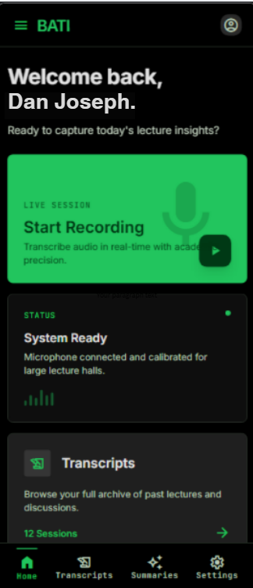

Figure 4. Home Screen
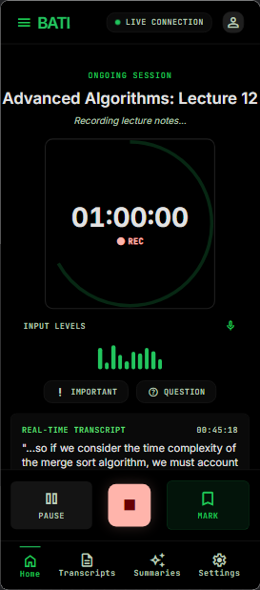
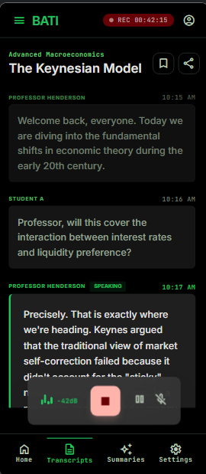
Home Screen: The application’s entry point, providing navigation to start a new recording session, view previously generated transcripts and summaries, enroll a teacher voice profile, and access system settings, designed for quick access with minimal interaction.

Figure 5. Recording Screen Interface
Recording Screen: Captures classroom audio for processing, displaying a recording status indicator and elapsed time with start and stop controls; the transcript grows continuously in the same view as speech is transcribed, though without live speaker or timestamp differentiation, which becomes available only after the session ends.

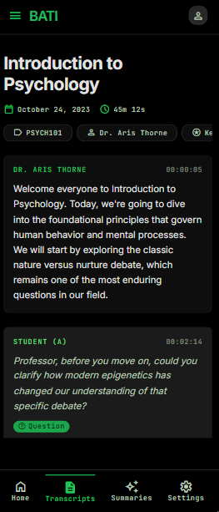

Figure 6. Transcript Screen Interface
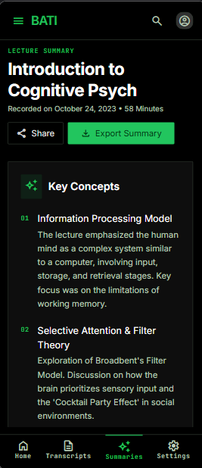
Transcript Screen: Displays the full per-segment transcript after a session ends, with each segment's timestamp, a speaker chip, and a distinct teacher indicator for identified teacher speech, alongside a search function that highlights matching text.

Figure 7. Structured Minutes Screen Interface
Structured Minutes Screen: Presents the system-generated classroom minutes as organized topics, key points, definitions, and assigned tasks rather than the full transcript, allowing quick review, with options to save or export for documentation.
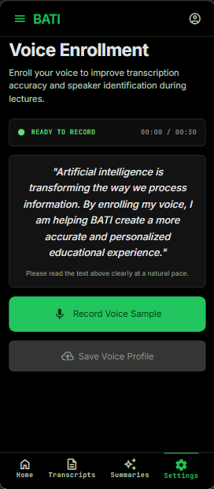
Figure 8. Teacher Voice Enrollment Interface
Teacher Voice Enrollment Screen: Allows instructors to record a voice sample that is analyzed and stored as a reference for teacher identification, enabling the system to recognize and prioritize teacher speech during transcription and summarization.
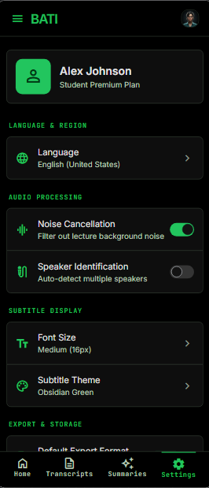
Figure 9. Settings Screen Interface
Settings Screen: Configures application preferences using outcome-based labels rather than technical parameter names for processing options — reducing background noise, skipping silent gaps, separating speakers with an optional speaker-count field, prioritizing the teacher's voice, and adjusting an accuracy-versus-speed balance — alongside connectivity settings for the backend server address and live update frequency, allowing the system to adapt to different classroom requirements while remaining understandable to students and teachers.

Environment
The prototype is developed and tested on a personal workstation running an AMD Ryzen 7 5700U processor, 16 GB of RAM, and an NVIDIA GeForce RTX 3050 with 4 GB of VRAM, running Windows 10/11 or Linux. Classroom audio is captured via Android smartphones over a local Wi-Fi network; testing is limited to Android devices, with iOS support outside the study's scope.
The backend is implemented in Python using FastAPI, with WebSocket handling continuous audio streaming, while the mobile application is built in Flutter. Audio preprocessing relies on FFmpeg for format conversion and noise suppression via the afftdn filter, with voice activity detection through Silero VAD. Speech recognition uses faster-whisper (small, int8 quantization), adapted to Hiligaynon through parameter-efficient fine-tuning using Low-Rank Adaptation (LoRA). Teacher voice prioritization uses SpeechBrain's ECAPA-TDNN speaker encoder via cosine similarity, prioritized over full multi-speaker diarization, which remains optional via pyannote.audio. Post-transcription processing uses glossary-based code-switch refinement and rule-based structuring via TextRank; data processing uses NumPy and Pandas, model adaptation uses HuggingFace Transformers and PEFT, and document export uses python-docx which are all open-source. Google Colab handles parameter-efficient fine-tuning and, when needed, model benchmarking; core development otherwise runs entirely within a local network, with no paid cloud services.

Testing and Evaluation
The purpose of testing and evaluation is to determine whether the developed prototype functions correctly, meets the system requirements, and produces usable instructional outputs under classroom-like conditions. The evaluation covers two areas: technical performance and user-based assessment. Technical evaluation measures the performance of the audio processing, transcription, teacher voice identification, post processing, and summarization pipeline, while user-based evaluation measures usability and related dimensions such as usefulness, comprehension support, and clarity of the system outputs.
Types of Testing
The system will undergo unit testing, integration testing, system testing, technical performance evaluation, including a baseline system comparison, and user-based evaluation.
Unit Testing will be conducted to check each system module separately audio capture, audio preprocessing, voice activity detection, speech segmentation, teacher voice enrollment, teacher voice identification, multilingual transcription, code-switch refinement, structured draft minutes generation, and output export, ensuring each module works correctly before integration into the complete system.
Integration Testing will verify whether the system modules work together as one processing pipeline. The tested flow involves the audio input, preprocessing, speech detection and segmentation, transcription with code-switch refinement, teacher voice identification, structured minutes generation, then output display/export. This ensures that audio data, speech labels, transcripts, and generated outputs are properly passed between modules.
System testing will evaluate the complete prototype using controlled or simulated classroom audio under different conditions, including clean audio, noisy audio, teacher-only speech, teacher-student interaction, monolingual speech, code-switched speed, and varying speaker distance, determining whether the complete system can generate near-real-time subtitles, transcripts with teacher prioritized segments, and structured draft classroom minutes.

Technical Performance Evaluation
Technical performance will be measured using manually prepared reference data and system-generated outputs. The following metrics will be used:
Evaluation area | Metric | Purpose
Transcription | Word Error Rate | Measures word-level transcription error
Teacher voice identification | Accuracy | Measures correct teacher/non-teacher classification
Teacher voice identification | Precision | Measures correctness of teacher-labeled segments
Teacher voice identification | Recall | Measures how many teacher segments are detected
Teacher voice identification | F1-score | Balances precision and recall
System responsiveness | Latency | Measures delay between audio input and generated output
System efficiency | Processing time | Measures backend processing time per audio chunk
Baseline system comparison | WER and processing time, Modified vs Base | Compares the complete fine-tuned system against an unmodified pretrained baseline
Table 1. Technical Performance Evaluation Metrics
Full multi-speaker diarization is not required for the core evaluation. If full diarization cannot be integrated within the project timeframe or hardware limits, the system will be evaluated through teacher/non-teacher speech classification at the segment level.
Baseline System Comparison
The complete system, consisting of the fine-tuned recognition model and the full processing pipeline, is compared against an unmodified baseline consisting of the pretrained Faster-Whisper model applied to FFmpeg-normalized audio only, without noise suppression, voice activity detection, glossary-based correction, or teacher voice identification; both configurations transcribe the same evaluation set to compare Word Error Rate and processing time, while teacher identification accuracy, precision, recall, and F1-score are reported for the complete system only, since the baseline performs no speaker verification.
This comparison determines whether the complete system, taken as a whole, improves recognition and delivers usable processing speed relative to an unmodified pretrained model. Because the two configurations differ in more than one component at once, it cannot isolate which specific component is responsible for any observed difference — only whether the complete system outperforms an off-the-shelf baseline, not which stage contributes how much. Results are reported as findings of the study regardless of the direction of the outcome.

User-Based Evaluation
User-based evaluation will be conducted with selected students and teachers after they use or review the prototype outputs, measured through the System Usability Scale, a standardized ten-item instrument scored on a five-point agreement scale and converted to a 0-100 score using the standard SUS procedure. Additional single-item questions, to be developed, will address perceived comprehension support, user experience, perceived usefulness, output clarity, and perceived accessibility support, alongside open-ended questions for comments and suggestions.
Testing Tools and Materials include Python-based scripts, collected or recorded classroom audio, teacher voice enrollment samples, reference transcripts, teacher/non-teacher segment labels, generated transcripts, and user questionnaire responses. Python scripts will compute WER, teacher identification metrics, and processing time for both the complete system and the baseline configuration. SUS responses are scored using the standard SUS algorithm, and open-ended responses are reviewed thematically.
Evaluation Procedure. This will be conducted in two stages. First, technical evaluation will be performed. dAudio samples will be processed by both the complete system and the baseline configuration, generated transcripts compared with reference transcripts to compute WER for each configuration, teacher/non-teacher segment labels compared with the complete systems predictions to compute accuracy, precision, recall, and F1-score, and system logs used to measure processing time for both configurations.
The expected outcome of the evaluation is to determine whether the prototype can process multilingual classroom audio, generate usable transcripts, identify teacher speech at the segment level, produce structured draft classroom minutes, and provide outputs that users find useful for classroom review. It is also expected to determine whether the complete system, with its fine-tuned model and full processing pipeline, improves recognition and processing speed relative to an unmodified pretrained baseline.
The results will also identify system limitations, including transcription errors, noisy audio issues, teacher identification errors, subtitle delay, weaknesses in structured minutes generation, and informing prototype refinement and future development recommendations.

Data Gathering Instrument
This study utilizes a combination of technical and user-centered data gathering instruments to collect relevant data for evaluating the performance and usability of the proposed system, gathering both quantitative data from system performance metrics and the SUS questionnaire, and qualitative data, from open-ended feedback on system usability and effectiveness.
The data gathering instruments include an Audio Recording Collection Form, a Reference Transcription Sheet, a System Testing Checklist, a Glossary and Term Correction Sheet, a System Performance Log, a Structured Minutes Evaluation Rubric, and a User Evaluation Questionnaire. The Audio Recording Collection Form documents metadata of recorded classroom audio such as language, noise-level, and number of speakers. The Reference Transcription Sheet serves as ground truth for transcription accuracy, with manually corrected text, speaker labels, and timestamps. The System Testing Checklist verifies component functionality across speech detection, teacher voice identification, transcription, and summarization,. The Glossary and Term Correction Sheet records targeted glossary terms and whether each correction was applied. The User Evaluation Questionnaire combines the standard System Usability Scale with additional single-item questions, to be developed, addressing perceived comprehension support, user experience, perceived usefulness, output clarity, and perceived accessibility support.
To ensure validity, the instruments are subjected to expert validation by the research adviser and selected panel members specializing in software development and educational technology, whose feedback refines unclear or irrelevant items. A pilot test will further assess clarity and comprehensibility, with revisions applied based on the results.
The reliability of the SUS instrument is supported by its established internal consistency in prior research, and Cronbach’s alpha is computed for any additional items to confirm they perform acceptably above 0.70.
Since the study involves recording classroom sessions and collecting feedback from students and teachers, ethical considerations are observed throughout data collection. Written informed consent is obtained from all participating teachers and students before any recording or evaluation activity, with parental or guardian consent secured for minors alongside school administration permission. Participants are informed of the study's purpose, how recordings are used, and their right to decline or withdraw at any time without consequence. Recorded audio, transcripts, and questionnaire responses are stored securely, used solely for this study, and handled in accordance with the Data Privacy Act of 2012 (Republic Act No. 10173); no personally identifying information appears in reported results, with speaker identities limited to teacher and non-teacher labels or anonymized designations.
Data collection is conducted in two phases: the first involves technical data collection using recorded audio and reference transcriptions for system evaluation, and the second involves user testing, where respondents interact with the system and complete the evaluation questionnaire.
All instruments are aligned with the objectives of the study, with technical tools assessing system performance and the questionnaire evaluating usability and related user-perceived qualities of the system.
Validity of the Instrument
The validity of the data gathering instruments is established to ensure that they accurately measure the technical performance and user-based evaluation areas relevant to the study. The primary user evaluation instrument, the System Usability Scale, is a standardized instrument with well-established validity and reliability from prior research, supplemented by additional single-item questions addressing perceived comprehension support, user experience, perceived usefulness, output clarity, and perceived accessibility support, designed to align with the objectives of the study and the features of the developed system.
The data gathering instruments include an Audio Recording Collection Form, a Reference Transcription Sheet, a System Testing Checklist, a Glossary and Term Correction Sheet, a System Performance Log, a Structured Minutes Evaluation Rubric, and a User Evaluation Questionnaire. These instruments are reviewed to ensure that they properly collect the data needed for technical evaluation, including transcription accuracy, teacher voice identification, and processing time. The Glossary and Term Correction Sheet records the glossary terms targeted for correction and whether each correction was applied, the System Performance Log captures processing time from system runs, and the Structured Minutes Evaluation Rubric guides the review of generated minutes.
To further strengthen validity, the instruments are subjected to expert validation. The research adviser and selected panel members review the instruments to evaluate the relevance, clarity, and completeness of each item, and their feedback is used to revise unclear, redundant, or irrelevant items and to ensure alignment with the study's objectives, system features, and evaluation metrics.
A pilot test is also conducted with a small group of respondents composed of high school students, college students, and teachers to assess the clarity, interpretability, and appropriateness of the questionnaire items, with necessary revisions made based on the results.
Through the use of a standardized usability instrument, supplementary items, technical evaluation forms, expert validation, and pilot testing, the study ensures that the instruments are valid, appropriate, and capable of measuring both user-perceived quality and technical performance of the proposed system.

Respondents of the Study
The respondents of this study will be composed of selected high school and college students, as well as teachers, from educational institutions within Iloilo City, Western Visayas. With a total of 15 students and 5 teachers, they are chosen for their direct involvement in classroom instruction and learning, where communication and code-switching are commonly observed.
This selection is appropriate since respondents are the system’s primary users and beneficiaries. Teachers as the main source of instructional content, students as recipients of classroom discourse, together providing insight into the system’s usability and effectiveness in real, multilingual classroom settings involving Hiligaynon, Filipino, and English.
Purposive sampling will be used, with participants chosen based on (1) current enrollment or active teaching at an academic institution, (2) experience in multilingual or code-switching environments, and (3) willingness to participate in the evaluation, ensuring respondents are directly relevant to the study’s objectives and capable of providing meaningful feedback.
Data Processing and Statistical Tool
This study utilizes both quantitative and qualitative data to evaluate the performance and usability of the proposed system. Quantitative data are obtained from system performance metrics and questionnaire responses, while qualitative data data are derived from open-ended feedback provided by respondents, with all data systematically organized and processed for accuracy and consistency.
For quantitative data, the five supplementary questionnaire items are encoded on a five point Likert scale ranging from 1 (Strongly Disagree) to 5 (Strongly Agree) and analuzed using frequency count, percentage, weighted mean, and standard deviation, tabulated with Microsoft Excel or Google Sheets. System Usability Scale respoonses are scored separately using standard SUS algorithm rather than a weighted mean, producing a single 0-100 score interpreted against established SUS benchmarks rather than the scale below.
Technical performance data are processed using Python-based evaluation scripts, using generated transcripts, reference transcripts, timestamps, teacher/non-teacher speaker labels, and system logs to compute Word Error Rate, teacher identification accuracy, precision, recall, F1-score, and processing time, with the same scripts comparing results between the complete system and the unmodified pretrained baseline.
Qualitative data from open-ended responses are analyzed through thematic coding, grouping responses into recurring themes such as usability, clarity of subtitles and transcripts, usefulness of structured minutes, accessibility support, and suggestions for improvement, complementing the quantitative for a more complete evaluation.

To interpret the results of the Likert-scale responses, the following scale is used:

TABLE III
MEAN SCALE AND INTERPRETATION
Scale | Interpretation
1.00 - 1.49 | Strongly Disagree
1.50- 2.49 | Disagree
2.50 - 3.49 | Undecided
3.50 - 4.49 | Agree
4.50 - 5.00 | Strongly Agree
Table 3. Mean Scale and Interpretation
The weighted mean and the scale above interpret the five supplementary items: user experience, perceived usefulness, perceived comprehension support, output clarity, and perceived accessibility support, while the System Usability Scale score is interpreted separately against its own benchmarks.. The technical metrics determine the system’s performance in transcription, teacher voice identification, and processing efficiency.
The results from both technical evaluation and user-based evaluation are analyzed together to determine whether the prototype meets the objectives of the study and to identify areas for improvement.

REFERENCES
[1] A. V. Muñoz, "Integrating Artificial Intelligence Across the Philippine Educational Continuum: Opportunities, Challenges, and Regulatory Frameworks to Foster Responsible AI Use from Primary to Graduate Levels for Sustainable Development," ResearchGate, Jun. 2025. [Online]. Available: https://www.researchgate.net/publication/392434248
[2] S. Mahdi, "Effective communication in learning: Teacher strategies and their impact on student learning outcomes," Int. J. Linguistics, Commun., Broadcast., vol. 1, no. 4, pp. 26–30, Sep. 2023, doi: 10.46336/ijlcb.v1i4.26.
[3] A. Chern, Y. H. Lai, Y. P. Chang, Y. Tsao, R. Y. Chang, and H. W. Chang, "A smartphone-based multi-functional hearing assistive system to facilitate speech recognition in the classroom," in 2017 IEEE 2nd International Conference on Cloud Computing and Big Data Analysis (ICCCBDA), Chengdu, China, 2017, pp. 405-408, doi: 10.1109/ICCCBDA.2017.7938619.
[4] A. Radford, J. W. Kim, T. Xu, G. Brockman, C. McLeavey, and I. Sutskever, "Robust Speech Recognition via Large-Scale Weak Supervision," arXiv, Dec. 6, 2022. [Online]. Available: https://arxiv.org/abs/2212.04356
[5] T. Xie, Y. Kuang, Y. Tang, J. Liao, and Y. Yang, "Using LLM-supported lecture summarization system to improve knowledge recall and student satisfaction," Expert Systems with Applications, vol. 269, Art. no. 126371, Apr. 2025, doi: 10.1016/j.eswa.2024.126371.
[6] J. D. B. Apilan, "Differences on the level of attention span among students," Health Research and Development Information Network (HERDIN), 2017. [Online]. Available: https://www.herdin.ph/index.php/herdin-home?view=research&cid=68999
[7] M. Klatte, K. Bergström, and T. Lachmann, "Does noise affect learning? A short review on noise effects on cognitive performance in children," Frontiers in Psychology, vol. 4, Art. no. 578, Aug. 2013, doi: 10.3389/fpsyg.2013.00578.
[8] S. M. T. Adlawan, Z. J. T. Amor, M. R. T. Estrella, R. R. T. Pengson, and A. C. M. Perido, "Bilingualism and multilingualism in primary education: Philippines," Grade 12 research project, De La Salle Health Sciences Institute Greenprints Repository, 2021. [Online]. Available: https://greenprints.dlshsi.edu.ph/grade_12/241/
[9] F. Gheller, G. Spicciarelli, P. Scimemi, and B. Arfé, “The effects of noise on children’s cognitive performance: A systematic review,” Environment and Behavior, vol. 55, no. 8–10, pp. 698–734, 2023, doi: 10.1177/00139165241245823.
[10] M. Foraster et al., "Exposure to road traffic noise and cognitive development in schoolchildren in Barcelona, Spain: A population-based cohort study," PLOS Medicine, vol. 19, no. 6, p. e1004001, Jun. 2022, doi: 10.1371/journal.pmed.1004001.
[11] B. B. Mangila, “Pedagogic code-switching: A case study of the language practices of Filipino teachers in English language classrooms,” English Language Teaching Educational Journal, vol. 1, no. 3, pp. 115–133, 2018, doi: 10.12928/eltej.v1i3.738.
[12] A. M. Ral, J. A. Amay, H. M. C. Buslon, C. R. B. Quilang, and J. B. Quiño-Justol, “Effect of code-switching in teaching among Filipino pre-service teachers,” Journal of Interdisciplinary Perspectives, vol. 4, no. 1, pp. 172–177, 2026, doi: 10.69569/jip.2025.740.
[13] Philippine Statistics Authority, "For every 10 Filipinos, 9 have basic literacy, while 7 have functional literacy (Final Results)," Jun. 30, 2025. [Online]. Available: https://psa.gov.ph/content/every-10-filipinos-9-have-basic-literacy-while-7-have-functional-literacy-final-results
[14] J. Sweller, “Cognitive load during problem solving: Effects on learning,” Cognitive Science, vol. 12, no. 2, pp. 257–285, 1988, doi: 10.1207/s15516709cog1202_4.
[15] J. Sweller, J. J. G. van Merriënboer, and F. Paas, “Cognitive architecture and instructional design,” Educational Psychology Review, vol. 10, no. 3, pp. 251–296, 1998, doi: 10.1023/A:1022193728205.
[16] F. Paas and J. J. G. van Merriënboer, “Cognitive-load theory: Methods to manage working memory load in the learning of complex tasks,” Current Directions in Psychological Science, vol. 29, no. 4, pp. 394–398, 2020, doi: 10.1177/0963721420922183.
[17] J. Sweller, J. J. G. van Merriënboer, and F. Paas, “Cognitive architecture and instructional design: 20 years later,” Educational Psychology Review, vol. 31, no. 2, pp. 261–292, 2019, doi: 10.1007/s10648-019-09465-5.
[18] R. C. L. Guevara, R. D. Cajote, M. G. A. R. Bayona, and C. R. G. Lucas, "Philippine Languages Database: A multilingual speech corpora for developing systems for low-resource languages," in Proc. 3rd Annu. Meeting Spec. Interest Group Under-resourced Lang. LREC-COLING, 2024, pp. 264–271. [Online]. Available: https://aclanthology.org/2024.sigul-1.32/
[19] D. S. Kuning and A. N. Haq, “English and Hiligaynon: Perception of English teachers about using translanguaging,” Premise: Journal of English Education and Applied Linguistics, vol. 13, no. 2, pp. 547–564, 2024, doi: 10.24127/pj.v13i2.9607.
[20] A. Mercugliano, A. Corbani, L. Bigozzi, G. Vettori, and O. Incognito, "The effects of classroom acoustic quality on student perception and wellbeing: A systematic review across educational levels," Frontiers in Psychology, vol. 16, Art. no. 1586997, 2025, doi: 10.3389/fpsyg.2025.1586997.
[21] R. E. Mayer, Multimedia Learning, 2nd ed. Cambridge, U.K.: Cambridge University Press, 2009, doi: 10.1017/CBO9780511811678.
[22] A. Orellana, E. Kanzki-Veloso, G. Arguello, and K. Wojnas, “Students’ experiences when using real-time automated captions and subtitles in live online presentations: A phenomenological study,” The Qualitative Report, vol. 29, no. 4, pp. 986–1012, 2024, doi: 10.46743/2160-3715/2024.6346.
[23] W. Qiao and C. Yijun, “The role of live transcripts in synchronous online L2 classrooms: Learning outcomes and learner perceptions,” Education and Information Technologies, vol. 28, pp. 14939–14961, 2023, doi: 10.1007/s10639-023-11784-8.
[24] R. Ranchal, T. Taber-Doughty, Y. Guo, K. Bain, H. Martin, J. P. Robinson, and B. S. Duerstock, “Using speech recognition for real-time captioning and lecture transcription in the classroom,” IEEE Transactions on Learning Technologies, vol. 6, no. 4, pp. 299–311, 2013, doi: 10.1109/TLT.2013.19.
[25] CAST, “Universal Design for Learning Guidelines version 2.2,” CAST, 2018. [Graphic organizer]. Available: https://udlguidelines.cast.org
[26] L. S. Vygotsky, Mind in Society: The Development of Higher Psychological Processes. Cambridge, MA, USA: Harvard University Press, 1978.
[27] International Organization for Standardization, “ISO/IEC 25010:2011 - Systems and software engineering - Systems and software quality requirements and evaluation (SQuaRE) - System and software quality models,” ISO, 2011. [Online]. Available: https://www.iso.org/standard/35733.html
[28] M. Goodwin, "What is latency?" IBM Think. [Online]. Available: https://www.ibm.com/think/topics/latency
[29] ISO 25000, "Performance efficiency," 2024. [Online]. Available: https://iso25000.com/index.php/en/iso-25010/performance-efficiency
[30] D. Macháček, R. Dabre, and O. Bojar, "Turning Whisper into real-time transcription system," in Proc. 13th Int. Joint Conf. Nat. Lang. Process. 3rd Conf. Asia-Pacific Chapter Assoc. Comput. Linguist. Syst. Demonstrations, 2023, pp. 17–24. [Online]. Available: https://aclanthology.org/2023.ijcnlp-demo.3
[31] Pertama Partners, "Audio segmentation," Pertama Partners Glossary. [Online]. Available: https://www.pertamapartners.com/glossary/audio-segmentation. [Accessed: Apr. 28, 2026].
[32] [32] Kutest Kids, "Classroom discourse: Definition & why it's important," Kutest Kids, Nov. 22, 2022. [Online]. Available: https://www.kutestkids.com/blog/classroom-discourse
[33] C. D. Morrison, "Code-switching | Linguistic Benefits & Challenges," Britannica, Mar. 25, 2026. [Online]. Available: https://www.britannica.com/topic/code-switching
[34] Texas Education Agency, "What research tells us about reading, comprehension, and comprehension instruction," Reading Rockets, 2002. [Online]. Available: https://www.readingrockets.org/topics/comprehension/articles/what-research-tells-us-about-reading-comprehension-and-comprehension
[35] ISO 25000, "Functional suitability," 2024. [Online]. Available: https://iso25000.com/index.php/en/iso-25000-standards/iso-25010/functional-suitability
[36] Merriam-Webster, "Hiligaynon," Merriam-Webster.com Dictionary. [Online]. Available: https://www.merriam-webster.com/dictionary/Hiligaynon. [Accessed: Apr. 27, 2026].
[37] M. Y. Tachbelie, S. T. Abate, and T. Schultz, "Multilingual Speech Recognition for Low-resource Languages," Proceedings of the 13th Language Resources and Evaluation Conference (LREC 2022), Marseille, France, 2022, pp. 2736–2744.
[38] Codefinity, "Noise Robustness in Machine Learning," Codefinity, 2024. [Online]. Available: https://codefinity.com/courses/v2/c02fddea-9e08-4c79-a785-499e3814bc0c/56f2af76-5a05-487a-ba90-2d30b74d9cd7/764a1a4a-76fa-4f33-9939-8202cf71fff4
[39] P. B. Bolodeoku, E. Igbinoba, P. O. Salau, C. K. Chukwudi, and S. E. Idia, "Perceived usefulness of technology and multiple salient outcomes: The improbable case of oil and gas workers," Heliyon, vol. 8, no. 4, Art. no. e09322, Apr. 2022, doi: 10.1016/j.heliyon.2022.e09322.
[40] C. Nguyen, "What is live captioning: Everything you should know," GoTranscript, Mar. 26, 2022. [Online]. Available: https://gotranscript.com/en/blog/what_is_live_captioning_everything_you_should_know
[41] J. Sintes, "Speaker diarization: An introductory overview," Medium, Jul. 17, 2023. [Online]. Available: https://lajavaness.medium.com/speaker-diarization-an-introductory-overview-c070a3bfea70
[42] COMPRISE, “Usage of speaker embeddings for more inclusive speech-to-text,” AIhub, Jun. 26, 2020. [Online]. Available: https://aihub.org/2020/06/26/usage-of-speaker-embeddings-for-more-inclusive-speech-to-text/
[43] Sustainability Directory, "Speaker identification accuracy," Sustainability Directory Glossary, 2024. [Online]. Available: https://esg.sustainability-directory.com/term/speaker-identification-accuracy/. [Accessed: Aug. 20, 2026].
[44] Z. Shi, "Speech recognition," in Intelligence Science, Elsevier, 2021, pp. 305–343. [Online]. Available: https://www.sciencedirect.com/topics/engineering/automatic-speech-recognition
[45] E. Z. Boris, "Classroom Minutes: A Valuable Teaching Device," Improving College and University Teaching, vol. 31, no. 2, pp. 70–73, 1983. [Online]. Available: https://www.jstor.org/stable/27565550
[46] IBM, "Transcript," IBM Documentation, May 16, 2023. [Online]. Available: https://www.ibm.com/docs/en/rpa/21.0.x?topic=general-transcript
[47] Picovoice, "Complete Guide to Voice Activity Detection (VAD)," Picovoice, Sep. 28, 2023. [Online]. Available: https://picovoice.ai/blog/complete-guide-voice-activity-detection-vad/
[48] RecFaces, "What is Voice Recognition? Definition, How It Works, & Main Usage," RecFaces, Dec. 12, 2023. [Online]. Available: https://recfaces.com/articles/what-is-voice-recognition
[49] A. NithyaKalyani and S. Jothilakshmi, "Speech summarization for Tamil language," in Intelligent Speech Signal Processing, Academic Press, 2019, pp. 201–217. [Online]. Available: https://www.sciencedirect.com/topics/computer-science/word-error-rate
[50] Australian Education Research Organisation, “Attention and focus,” EdResearch Explainers, 2025. [Online]. Available: https://www.edresearch.edu.au/summaries-explainers/explainers/attention-and-focus.
[51] Voyager Sopris Learning, “Comprehension: Defining the Key to Understanding,” Voyager Sopris Blog, Sep. 2023. [Online]. Available: https://voyagersopris.com/vsl/blog/comprehension-defining-the-key-to-understanding.
[52] E. H. Fernandez and B. H. Arriola, "Reading and comprehension skills of primary learners in selected elementary school," Int. J. Multidisciplinary Research and Publications (IJMRAP), vol. 5, no. 5, pp. 149–155, 2022.
[53] H. Alindayu, K. Cristobal, A. Jose, E. Palattao, A. Panganiban, and D. Rivera, "Reading Performance Level and Factors Affecting Comprehension Abilities of Junior High School Students: A Basis for Competency-Based Reading Intervention Program," ISUEC Journal, vol. 2, no. 1, pp. 134-149, 2025. [Online]. Available: https://www.ejournals.ph/article.php?id=30849
[54] Svantek, “Noise in schools,” Svantek Academy, 2024. [Online]. Available: https://svantek.com/academy/noise-in-schools/.
[55] L. Villanueva and B. Gamiao, "Effects of Code Switching Among College Instructors and Students In a Philippine Classroom Setting," *American Journal of Multidisciplinary Research and Innovation*, vol. 1, no. 2, pp. 70–77, 2022. doi: 10.54536/ajmri.v1i2.2
[56] J. Bardinas, S. Campos, K. Tacang, and J. T. Minoza, "Code-switching in multilingual classrooms: A bridge or a barrier to language proficiency?" J. Educ. Learn. Environ., vol. 1, no. 2, pp. 76–88, Dec. 2025, doi: 10.55121/jele.v1i2.886.
[57] X. de Zuazo, E. Navas, I. Saratxaga, and I. Hernáez Rioja, "Whisper-LM: Improving ASR models with language models for low-resource languages," arXiv:2503.23542, Mar. 2025.
[58] S. Dua and P. Bansal, "Noise robust automatic speech recognition: Review and analysis," Int. J. Speech Technol., vol. 26, no. 3, pp. 587–612, 2023, doi: 10.1007/s10772-023-10033-0.
[59] A. Aquino and A. Tsang, "G2P and ASR techniques for low-resource phonetic transcription of Tagalog, Cebuano, and Hiligaynon," in Proc. 13th Linguistic Annotation Workshop, Florence, Italy, 2019, pp. 1–10, doi: 10.18653/v1/W19-4001
[60] M. B. Mustafa, M. A. M. Yusoof, Z. M. Don, and N. H. A. H. Malim, "Code-switching in automatic speech recognition: The issues and future directions," Appl. Sci., vol. 12, no. 19, Art. no. 9541, 2022, doi: 10.3390/app12199541.
[61] H. Liu, H. Zhang, Q. Zhang, X. Zhang, D. Shi, E. S. Chng, and H. Li, "Code-switching speech recognition under the lens: Model- and data-centric perspectives," arXiv:2509.24310, Sep. 2025.
[62] A. A. Attia, D. Demszky, T. Ogunremi, J. Liu, and C. Espy-Wilson, "CPT-boosted Wav2vec2.0: Towards noise robust speech recognition for classroom environments," arXiv, Sep. 2024. [Online]. Available: https://arxiv.org/abs/2409.14494
[63] K. Kuhn, V. Kersken, B. Reuter, N. Egger, and G. Zimmermann, "Measuring the accuracy of automatic speech recognition solutions," ACM Trans. Access. Comput., vol. 16, no. 4, Art. no. 25, pp. 1–23, Jan. 2024, doi: 10.1145/3636513.
[64] J.-M. Valin, “A hybrid DSP/deep learning approach to real-time full-band speech enhancement,” in Proceedings of the IEEE Multimedia Signal Processing Workshop (MMSP), 2018. [Online]. Available: https://arxiv.org/abs/1709.08243
[65] H. Bredin, “pyannote.audio 2.1 speaker diarization pipeline: Principle, benchmark, and recipe,” in Proceedings of INTERSPEECH 2023, 2023, doi: 10.21437/Interspeech.2023-105.
[66] S. E. Tranter and D. A. Reynolds, "An overview of automatic speaker diarization systems," IEEE Trans. Audio, Speech, Lang. Process., vol. 14, no. 5, pp. 1557–1565, Sep. 2006, doi: 10.1109/TASL.2006.878256.
[67] A. Plaquet and H. Bredin, “Powerset multi-class cross entropy loss for neural speaker diarization,” in Proceedings of INTERSPEECH 2023, 2023, doi: 10.21437/Interspeech.2023-205.
[68] E. Pacheco, A. Orhon, B. Durmus, B. Munyampirwa, and A. Leonov, "Benchmarking diarization models," arXiv preprint, arXiv:2509.26177, 2025.
[69] A. Plaquet, N. Tawara, M. Delcroix, S. Horiguchi, A. Ando, and S. Araki, "Mamba-based segmentation model for speaker diarization," in Proc. ICASSP 2025 – IEEE Int. Conf. Acoustics, Speech Signal Process., Apr. 2025, pp. 1–5, doi: 10.1109/ICASSP49660.2025.10889446.
[70] V. Khoma, Y. Khoma, V. Brydinskyi, and A. Konovalov, “Development of supervised speaker diarization system based on the PyAnnote audio processing library,” Sensors, vol. 23, no. 4, Art. no. 2082, 2023, doi: 10.3390/s23042082.
[71] B. Desplanques, J. Thienpondt, and K. Demuynck, “ECAPA-TDNN: Emphasized channel attention, propagation and aggregation in TDNN based speaker verification,” in Proceedings of INTERSPEECH 2020, 2020, pp. 3830–3834, doi: 10.21437/Interspeech.2020-2650.
[72] J. Thienpondt, B. Desplanques, and K. Demuynck, “ECAPA-TDNN embeddings for speaker diarization,” in Proceedings of INTERSPEECH 2021, 2021, pp. 3560–3564, doi: 10.21437/Interspeech.2021-865.
[73] SYSTRAN, “faster-whisper: Faster Whisper transcription with CTranslate2,” GitHub, 2023. [Software]. Available: https://github.com/SYSTRAN/faster-whisper
[74] J. A. Teves et al., "HiligayNER: A baseline named entity recognition model for Hiligaynon," in Proc. 39th Pacific Asia Conf. Lang. Inform. Comput., 2025, pp. 772–779. [Online]. Available: https://aclanthology.org/2025.paclic-1.71/
[75] E. J. Hu et al., "LoRA: Low-rank adaptation of large language models," in Proc. Int. Conf. Learning Representations (ICLR), 2022. [Online]. Available: https://arxiv.org/abs/2106.09685

